Real Time Systems Laboratory
ELCT 302-001
Nicholas George

Lab Notebook

Group 2 (Short Circuits)
Driving Team

Department of Electrical Engineering
University of South Carolina
Columbia, SC 29208

Table of Contents
Table of Contents 1
Lab 01: Open-Loop Control & Obtaining Feedback 1
General Objectives 1
Main Specifications 1
Tasks: Open-Loop Control 1
Tasks: Speed Measurement 1
Background 1
Calculations 1
Code 1
Results 1
Problems Encountered 2
Questions 2
Time sheet 2
Lab 02: Model Identification 3
General Objectives 3
Main Specifications 3
Tasks: Part I 3
Tasks: Part II 3
Background 3
Calculations 3
Code 3
Results 3
Problems Encountered 5
Questions 5
Requirements 5
Time Sheet 5
Lab 03: 6
General Objectives 6
Main Specifications 6
Tasks: Motor Control Design and Simulation 6
Tasks: Controller Implementation 6
Background 6
Calculations 6
Code 6
Results 6
Problems Encountered 6
Questions 6
Requirements 6
Time Sheet 6
Component Specifications (Data Sheets) 7
Mbed Pinout 7
Mbed Datasheet 7
MOSFET (IRF540NPBF) Datasheet 7
Schottky Diode (MBR1060-E3/45) Datasheet 7
Motor (RN260-CN-18130) Datasheet 7
Voltage Regulator (L7805CV) Datasheet 7
Low-Side Gate Driver (TC4428EPA) Datasheet 7
Optical Sensor (OPB829AZ) Datasheet 7
Frequency to Voltage Converter (LM2907N/NOPB) Datasheet 7

Lab 01: Open-Loop Control & Obtaining Feedback
Motor Control (Group A)

General Objectives
- Use programming techniques to solidify understanding of microcontroller features.
  - API is available on MBed.com for the KL25Z GPIO drivers under MbedOS section.
- Demonstrate understanding and implementation of open-loop DC motor control
  - Single switch buck converter.
- Design and implement a circuit to create a feedback signal for motor speed
  - Design and implement an encoder.
  - Design a frequency to voltage converter.
- Determine speed to voltage relationship of the DC motor.

Main Specifications
- Motor voltage: 7.2V
- Switching frequency: ≥20 kHz
- Speed range: 0-100% (Design to match the DC motor’s rated voltage!!!)
- External voltage (speed) reference: 0-3.3V
- Feedback: Incremental Encoder

Tasks: Open-Loop Control
- Research data sheets for components and understand why they are used (their ratings)
- Design an adjustable voltage divider (Potentiometer) circuit with an output ranging from 0 - 3.3V.
- Write code that reads in the voltage divider output as an ADC number and writes the ratio to the desired maximum as the PWM duty cycle.
- Upload and verify with microcontroller. (Keep in mind the DC motor’s voltage rating!!) (Hint: Lab 0)
- Build buck converter and verify its operation
Tasks: Speed Measurement
- Research the LM2907 and Optical Switch sensor datasheets; understand the operation of both circuits
- Design frequency-to-voltage converter (LM2907) and circuitry for Optical Switch sensor using information from lecture and datasheets
- Tabularize motor control and feedback measurement range and summarize results:
  - Vref (V), reference voltage measured from potentiometer
  - Vref ADC, reference voltage digital conversion
  - Duty Cycle (0-1), positive duty cycle
  - Fencoder, Encoder frequency (Hz)
  - Vout (V), speed measurement in volts from speed sensor
  - Vout ADC, speed measurement voltage digital conversion
  - Wheel Speed (rad/s) o Motor Speed (rad/s)
  - Average motor voltage (V): Vdc*duty-cycle (0-1)

Background
- Circuit Diagram
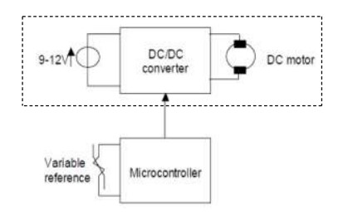
- Reference Voltage
For the external reference voltage, a potentiometer is used as a voltage divider. The input to the potentiometer will be from the 3.3V pin of the KL25Z microcontroller. The output (voltage dependent on the potentiometer wiper location) will be directed into an analog input pin of the microcontroller.
$$V_{out}=\frac{R_{2}}{R_{1}+R_{2}}⋅V_{in}$$
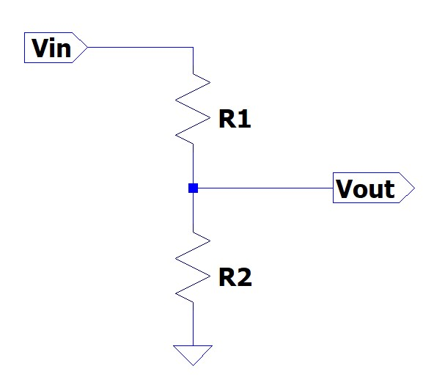
- Microcontroller
  - Analog-Digital-Converter (ADC)
A basic ADC circuit is comprised of comparators. A voltage input ($V_{IN}$) signal is applied to the input of the comparator, while a reference voltage ($V_{REF}$) is applied to the other. A comparison of the voltages is made, and the output of the comparator will either be high or low.
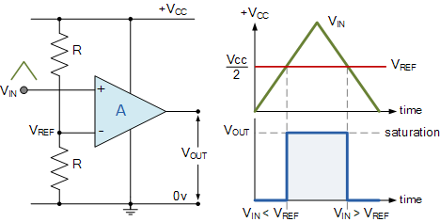
One comparator could be considered a 1-bit ADC. To increase the bit size of the ADC, comparators are stacked. The general equation is:
$$n-bit ADC = 2^{n}-1$$
The KL25Z utilizes a 16-bit (65,536 distinguishable outputs) ADC and uses an AnalogIn API to read an external voltage applied to an analog input pin (3.6V max input voltage to pin). The resolution of the ADC and be calculated to find the amount of voltage required to make a change in the digital output.
$$\frac{V_{max}}{distinguishable outputs}$$
The voltage is read as a fraction of the system voltage. This value is a floating point from 0.0(VSS) to 1.0(VCC). A change in analog input voltage, given by the equation above, will create a change in the digital output voltage by;
$\frac{1}{distinguishable outputs}$

  - Pulse Width Modulation (PWM)
PWM is a train of continuous pulses, where the start of each pulse is separated by a constant time. The time it takes for each pulse is defined as the period (T) of the waveform and is inversely proportional to the frequency (f).
$$T = \frac{1}{f}$$
The duty cycle is the relationship between the time on and time off
$$D= \frac{T_{on}}{T_{on}+T_{off}}=\frac{T_{on}}{T}$$
With the output waveform of the PWM being a square wave, the voltage output of the PWM will be equal to the average voltage.
$$V_{out}= V_{in}⋅D$$

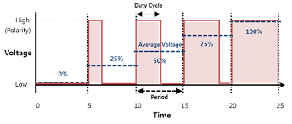
It should be noted that the KL25Z microcontroller’s 16-bit ADC can operate at frequencies of 2 to 12 MHz or up to 83.33 ns. While the GPIO can operate at up to 62.5 MHz or 16 ns.

- DC/DC Converter
To generate and control voltage for the DC motor a DC/DC converter will be utilized. The motor’s speed is linearly proportional to the voltage, so the voltage needs to be as accurate as possible. Using the PWM signal from the microcontroller and a switch, a desired voltage can be created to control the motor speed. The desired DC signal needs to filter out the lower fundamental frequencies and harmonics.
  - Low-Side Gate Driver
One inverting, one non-inverting = flipped waveform.

  - MOSFET
An N-channel MOSFET will be utilized as the switch for the converter. A MOSFET has a gate, source, drain, and body. Typically, the source and body are internally connected. When a voltage is applied to the gate-source ($V_{GS}$), and it is higher than the threshold voltage ($V_{th}$) of the MOSFET, current will flow.
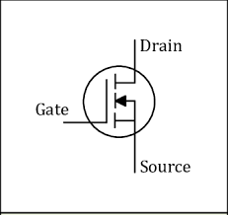
Drain current ($i_{D}$) is dependent on the K value and voltage threshold of the MOSFET and the voltages applied at the gate and drain. It is also dependent on the operating region as well.
$$K=\frac{W}{L}⋅\frac{KP}{2}$$

$$KP=μ_{n}⋅C_{ox}$$
There are three regions the MOSFET operates. The cut-off region occurs when $V_{GS}<V_{th}$. The triode region occurs when, $V_{GS}>V_{th}$ but the drain-source voltage ($V_{DS}$) is less than the difference of the two $V_{DS}<\left(V_{GS}-V_{th}\right)$. The current in the triode region is,
$$i_{D}=K\left[2\left(V_{GS}-V_{th}\right)V_{DS}-V_{DS}^{2}\right]$$
The saturation region occurs when $V_{DS}≥\left(V_{GS}-V_{th}\right)$. The current in the saturation region is,
$$i_{D}=K{\left(V_{GS}-V_{th}\right)}^{2}$$
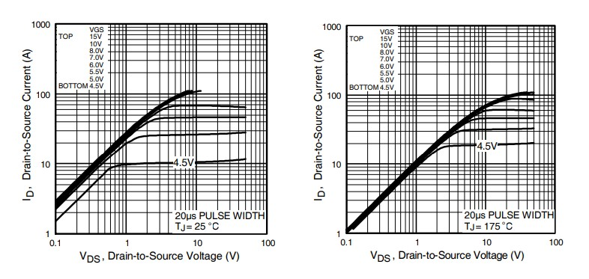
It is important to note that the specifications for the MOSFET utilized has a pulse width ≤ 400µs; duty cycle ≤ 2%.

  - Schottky Diode
The Schottky diode is a type of metal–semiconductor junction diode. This diode is formed by the junction of a semiconductor with a metal. Schottky diode offers fast switching action and has a low forward voltage drop.
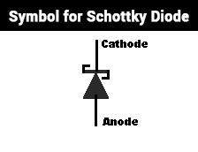
Current is the dependent variable while voltage is the independent variable in the Schottky diode.
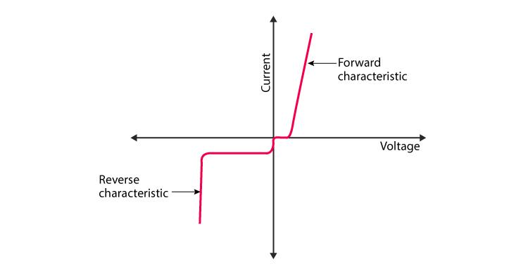
  - Buck Converter
The motor utilized operates at a lower voltage than the voltage source. The buck converter will step down the voltage supplied to the operating voltage of the motor.
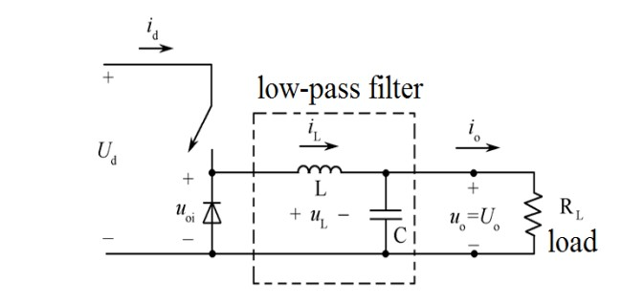
To reduce voltage ripple, filters made of capacitors are normally added. However, the motor’s own inductance acts like a filter, storing energy during the “on” cycle while releasing it at a rate corresponding to the input or reference signal. The buck converter’s switch can be located on the high-side or the low-side. The low-side configuration will be used with the MOSFET discussed earlier.

  - Speed Measurement
To calculate the speed of the vehicle, the difference between the desired speed and real speed must be measured. An optical sensor will determine the frequency of tire rotation. Phototransistor switching occurs when an opaque object passes through the slot of the device. The frequency of the output depends on the speed between on and off transitions.
This frequency will need to be changed into a voltage, so that the “actual” speed voltage can be compared to the “desired” speed voltage. A frequency to voltage converter can accomplish this task. The input frequency provided by the sensor is filtered through a Schmitt trigger. This reduces the noise from the input signal. The filtered signal is then sent to a charge pump that converts the signal frequency to a DC voltage.
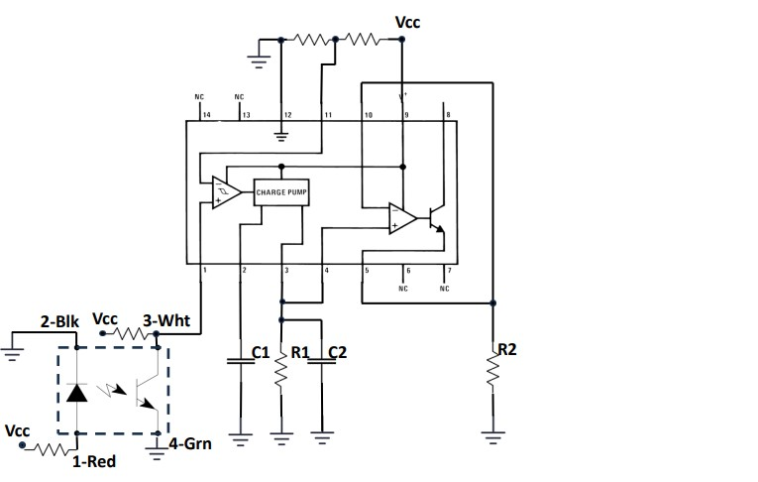
Additional components are added to the frequency to voltage converter. Resistors and capacitors are needed to supply the charge pump with internal compensation. The values of the components can alter the response time, linearity, and ripple of the output. The following calculations are used to:
$$V_{o}=V_{cc}⋅f_{in}⋅C_{1}⋅R_{1}⋅K \left(Where K=1\right)$$
$$R_{1}≥\frac{V_{o,max}}{i_{3,min}}$$
$$f_{max}=\frac{I_{2}}{C_{1}⋅V_{cc}}$$
$$V_{ripple}=\left(\frac{V_{cc}}{2}\right)⋅\left(\frac{C_{1}}{C_{2}}\right)⋅{\left(1-\left(\frac{V_{cc}⋅f_{in}⋅C_{1}}{I_{2}}\right)\right)}_{pk-pk}$$
$$=\left(\frac{V_{cc}}{2}\right)⋅\left(\frac{C_{1}}{C_{2}}\right)⋅{\left(1-\left(\frac{V_{o}}{I_{2}⋅R_{1}}\right)\right)}_{pk-pk}$$

Calculations
- ADC
$$\frac{3.3 V}{65,536}=50μV$$
$$\frac{1}{65,536}=15μV$$

- Tachometer
Resistors for sensor
$$R_{1}≥\frac{3.3V}{180μA}=18.33kΩ$$
$$C_{1}≥500pF$$
$$R_{2}=10kΩ$$
$$C_{2}=1μF$$
$$V_{o}=5V⋅1nF⋅20kΩ⋅1⋅f_{in}$$

Code
#include "mbed.h"
//#include "unistd.h"
//#include "pinmap.h"

// Voltage into the microcontroller from the voltage divider
AnalogIn potV(A0);
// Voltage into the microcontroller from the right motor speed
AnalogIn rmV(A1);
// Voltage into the microcontroller from the right motor speed
AnalogIn lmV(A2);
// Pulse width to the right motor
PwmOut poutRM(D0);
// Pulse width to the right motor
PwmOut poutLM(D1);

// Instantiate variables
float vref = 0.0;
float vrm = 0.0;
float vlm = 0.0;
// Code for print function on tera term
static BufferedSerial serial_port(USBTX, USBRX, 9600);
FileHandle *mbed::mbed_override_console(int fd)
{
return &serial_port;
}
// Main code
int main() {

// Set period of pulse widths
//poutRM.period_us(40);
//poutLM.period_us(40);
poutLM.period(1.0f/25E3f);
poutRM.period(1.0f/25E3f);
// While motor running
while (1) {

// Read the incoming voltage from pot
vref = potV.read();

// Print digital voltage input
printf("Digital voltage input %1.4f\r", vref);

//Send pulse width according to inverted duty cycle. The waveform is flipped at the gate driver.
poutRM.write(1.0f-vref);
poutLM.write(1.0f-vref);

// Read incoming voltage from wheel speed
vrm = rmV.read();
vlm = lmV.read();

// Print wheel speed voltage values
printf("Voltage right motor %1.4f\r", vrm);

printf("Voltage left motor %1.4f\r", vlm);

//Wait
//usleep(40);
}
}

Results
- $0.6 V_{ref}$
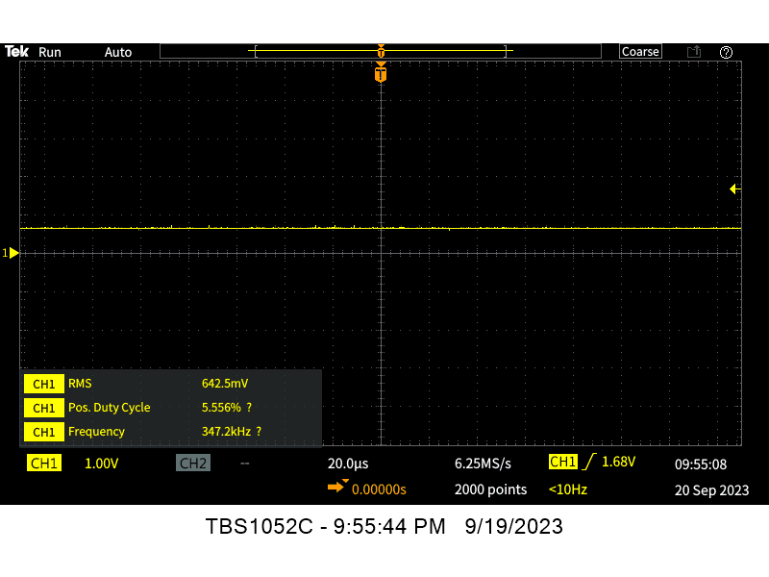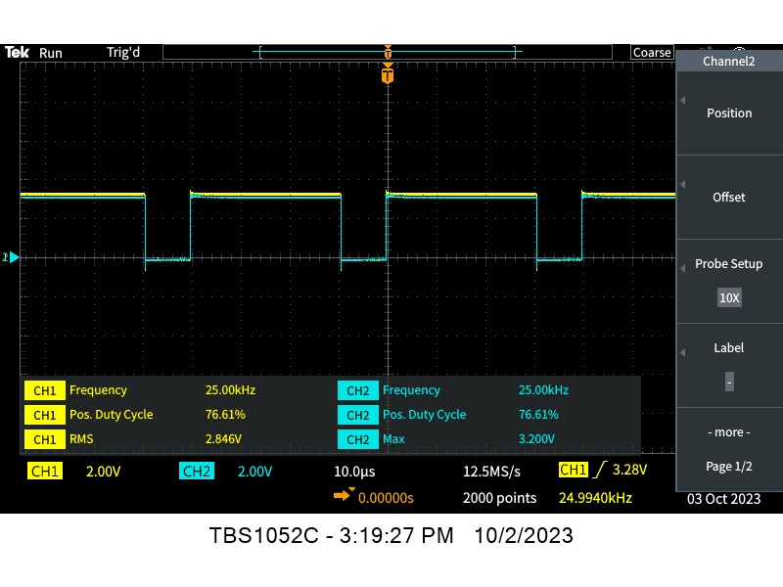
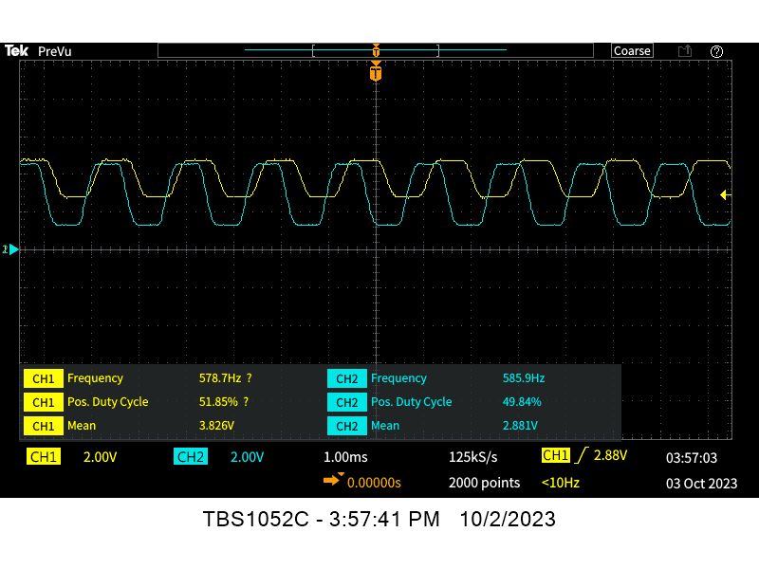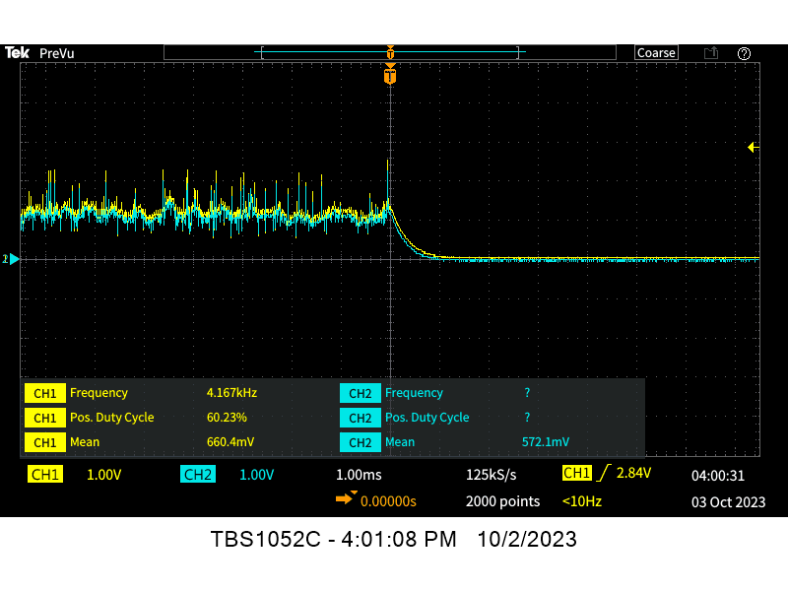

- $1.32 V_{ref}$
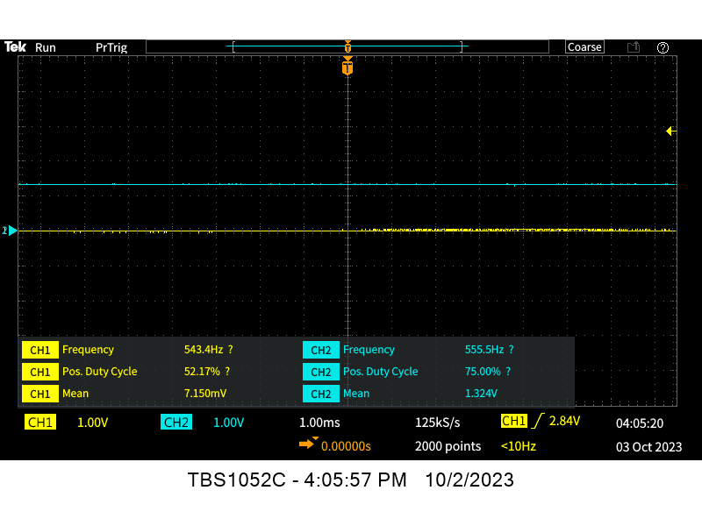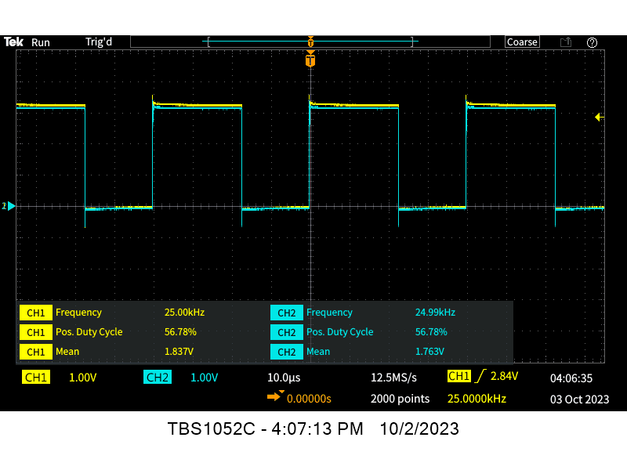
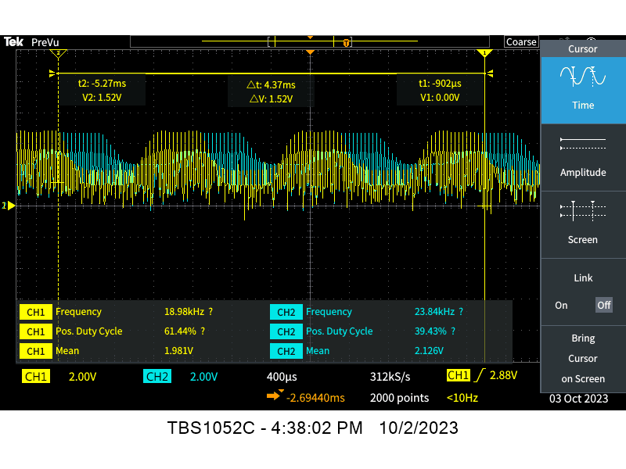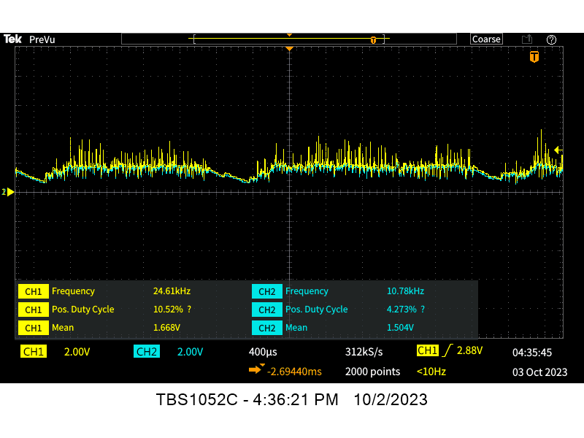

- $2.0 V_{ref}$
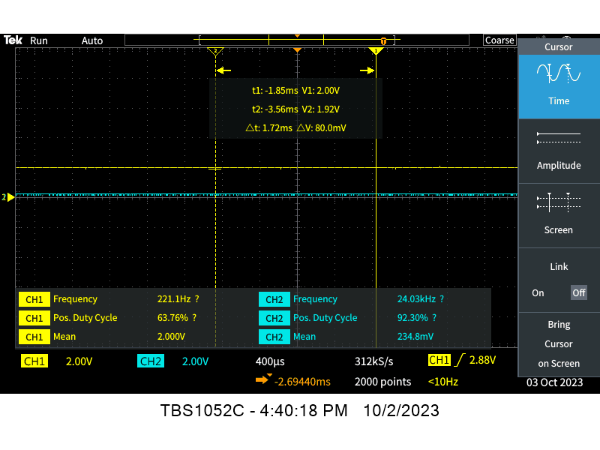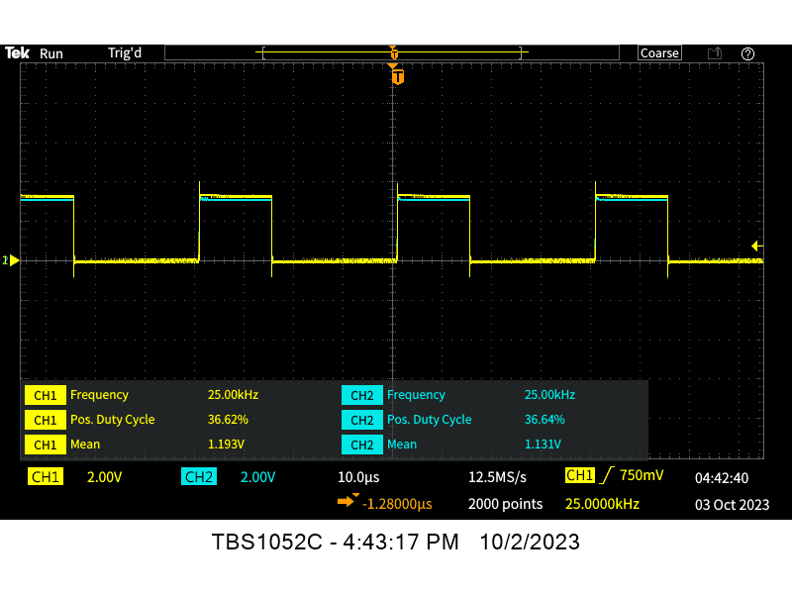
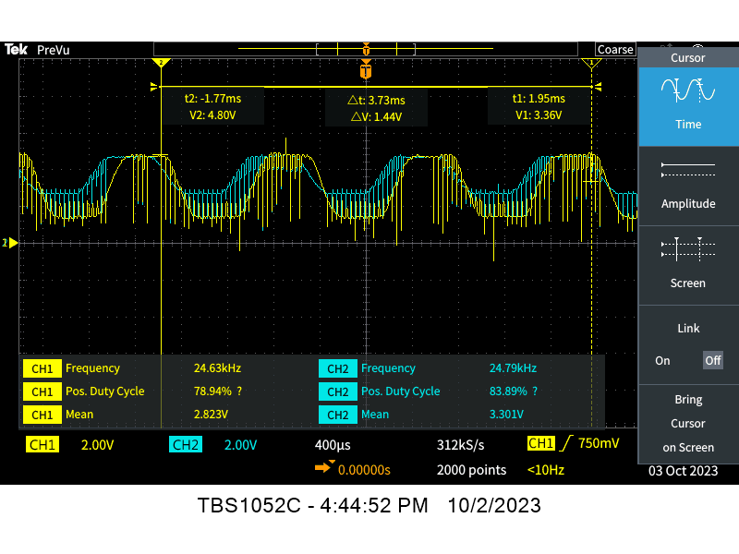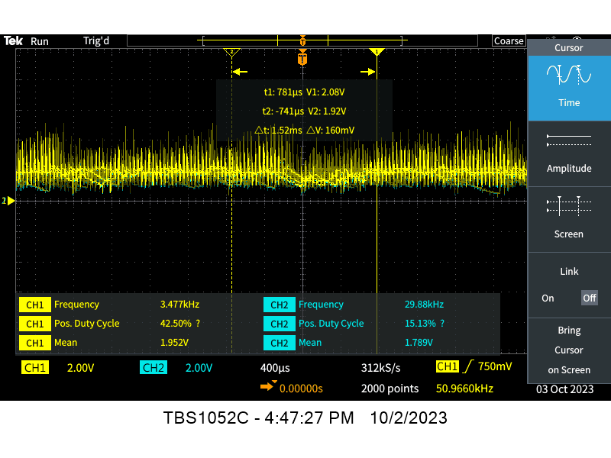

- $2.64 V_{ref}$
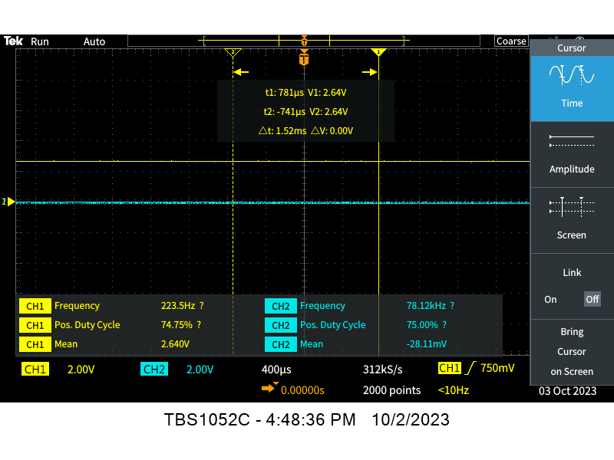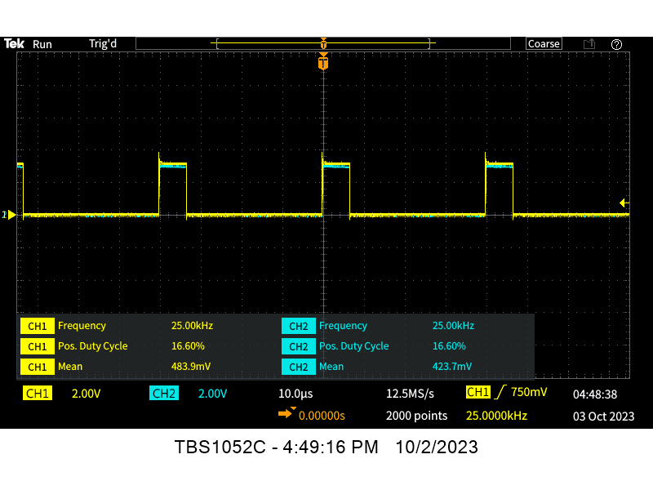
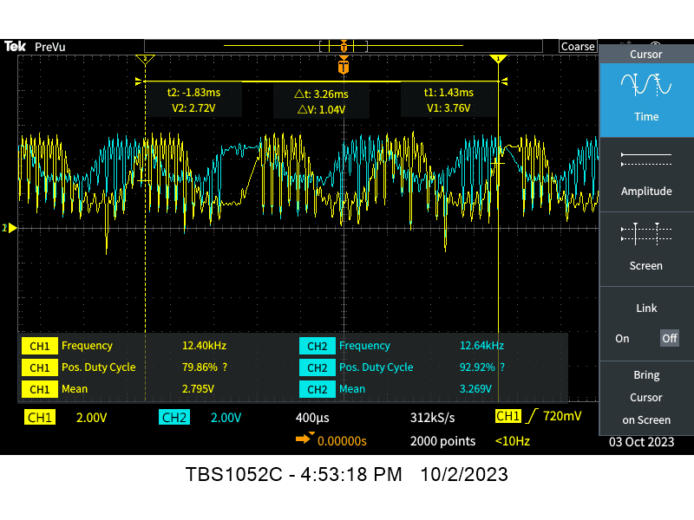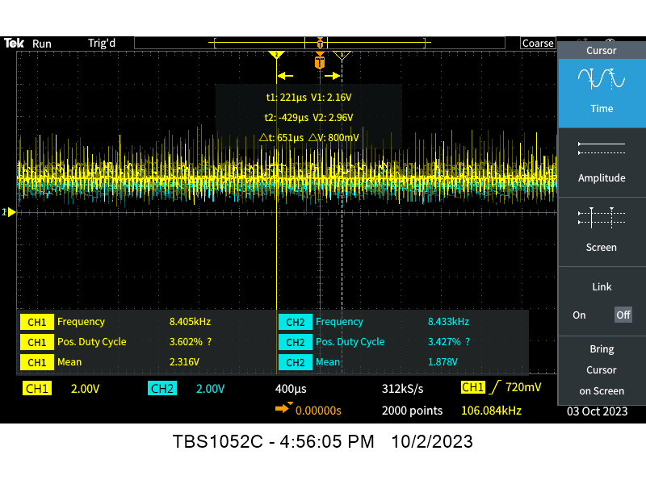

- $3.28 V_{ref}$
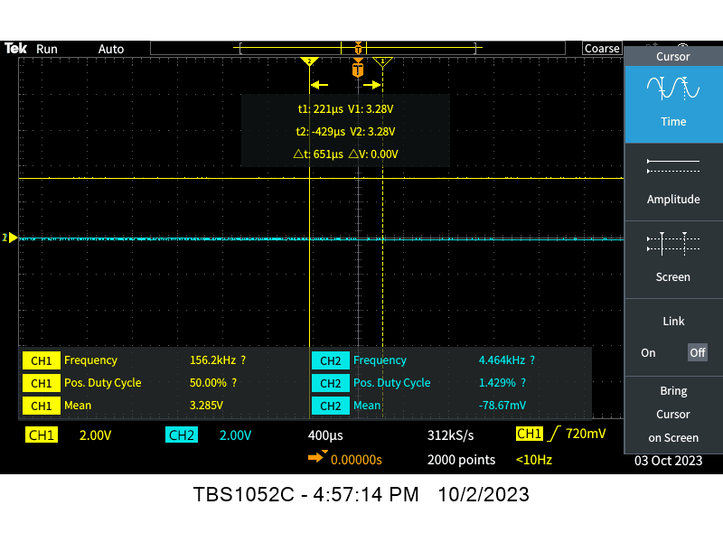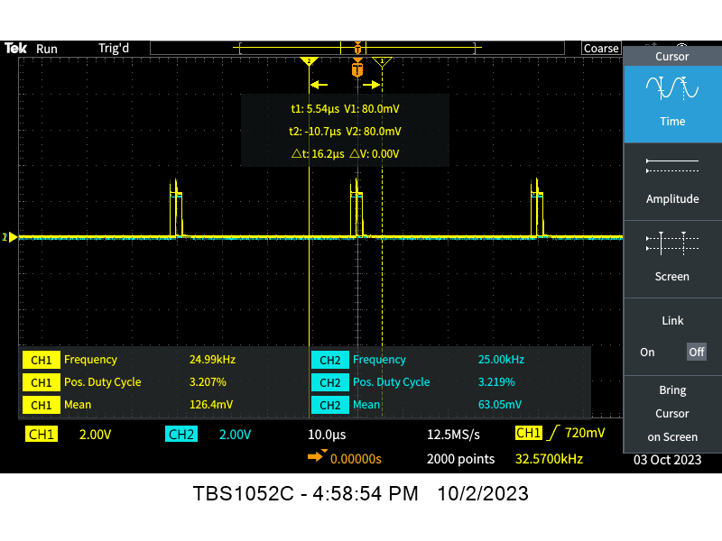
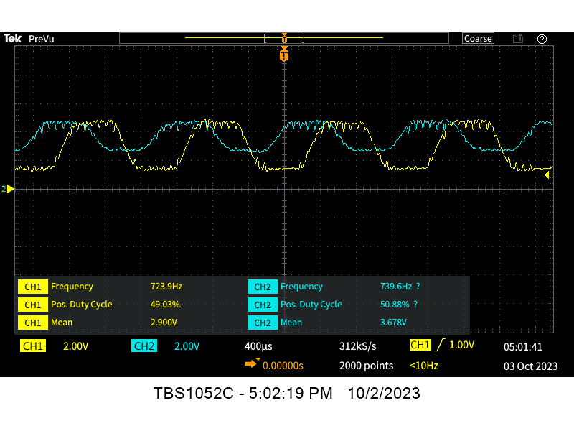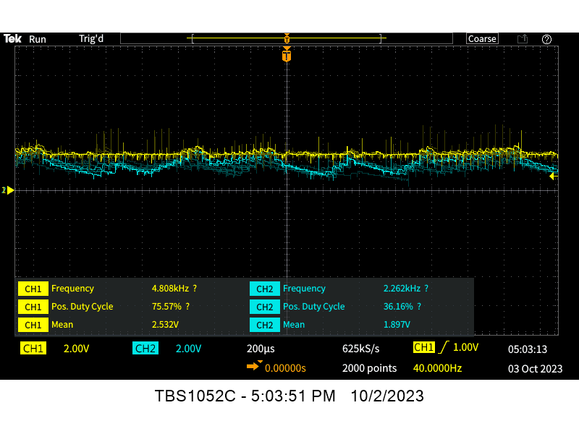

Table and Graph Results
Vref (V) | VrefADC | Duty Cycle | Fencoder L (Hz) | Fencoder R (Hz) | Vout L (RMS) | Vout R (RMS) | VoutADC | Wheel Speed L | Wheel Speed R | Motor Speed L | Motor Speed R
0.66 | 0.2 | 0.24 | 578 | 585 | 0.66 | 0.57 | 0.172727 | 36.125 | 36.5625 | 270.9375 | 274.21875
1.32 | 0.4 | 0.44 | 687 | 699 | 1.67 | 1.5 | 0.454545 | 42.9375 | 43.6875 | 322.03125 | 327.65625
1.99 | 0.6 | 0.632 | 806 | 787 | 1.95 | 1.79 | 0.542424 | 50.375 | 49.1875 | 377.8125 | 368.90625
2.64 | 0.8 | 0.83 | 926 | 926 | 2.32 | 1.88 | 0.569697 | 57.875 | 57.875 | 434.0625 | 434.0625
3.28 | 0.99 | 0.966 | 724 | 740 | 2.53 | 1.9 | 0.575758 | 45.25 | 46.25 | 339.375 | 346.875

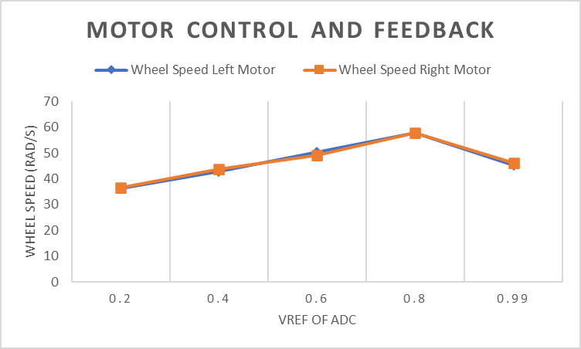

Problems Encountered
- When switching from the OS-2 system of the micro controller to the OS-6, the printf function worked. However, the API functions of AnalogIn and PWMout did not work properly anymore.
- Voltage decreased when the duty cycle increased. The low-side gate driver was inverting the input signal. So, the code was adjusted to account for this inversion.
- The optical sensor was not able to properly produce a frequency relative to the wheel speed at high speeds. This may be due to a fault with the optical sensor or the slits in the wheel. As shown below, the sensor can only realize a few of the slits per one full-wheel rotation. Which in turn limited the output voltage from the voltage to frequency converter.
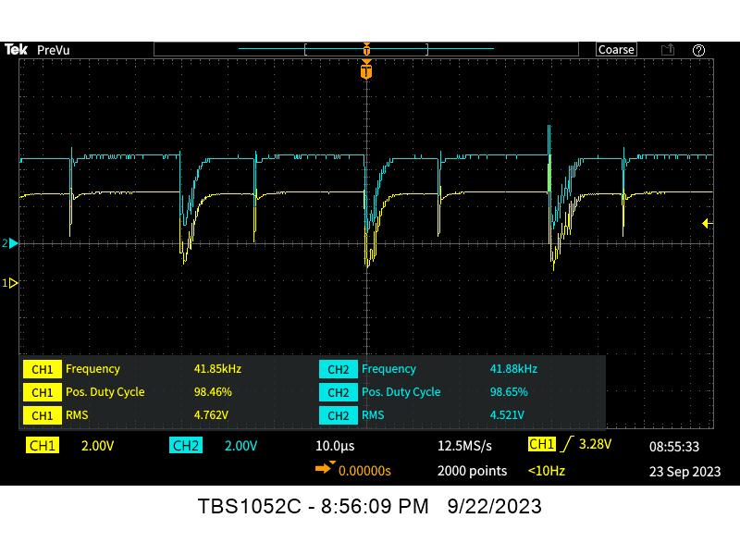
Missing Signal
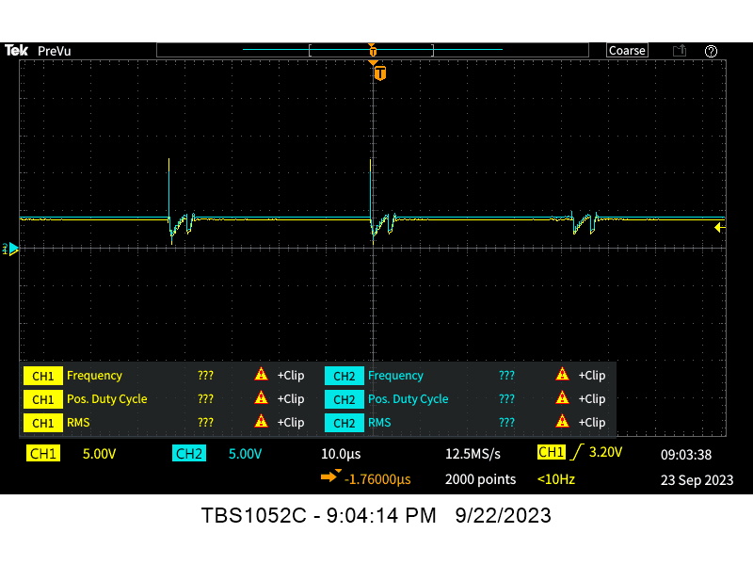
Missing Signals
Upon further inspection, the sensor was defective. We replaced the sensor and began to receive signals that were more accurate.

Questions
- Why is the gate driver needed? VGS? VDS?
The gate driver is needed to boost the current supplied by the PWM of the micro-controller.
- Why do we use a MOSFET? Why not a BJT?
MOSFETs are voltage-controlled and BJTs are current-controlled. We want a linear relationship between voltage and motor speed. So, we utilize a MOSFET.
- In what mode(s) does a MOSFET act as a switch? An amplifier? How does this differ?
MOSFET’s have three modes. Cut-off, triode and saturation. It will act as a switch in the cut-off and saturation region. It will act as an amplifier in the triode region.
- Will the circuit in Figure 1 work without the diode? Explain.
The circuit in Figure 1 does not include a diode. It will work without a diode. However, a diode should be placed after the microcontroller to prevent damage to the microcontroller. We don’t want the microcontroller to draw current from the circuit from the motor's internal capacitance.
- Why do we use low-side configuration? (Hint: With a 7.2V Battery would the MOSFET turn completely off in high-side configuration? Justify.)
A low side configuration is used due to the low conduction losses given at higher duty cycles. This configuration includes analysis for power loss and has great efficiency with the gate driver.

Time sheet
Name | Date | Start Time | End Time | Total Time Spent | Tasks / Notes
Nicholas George | 09/06/2023 | 20:00 | 21:30 | 1 Hr. 30 Min. | Created Lab Notebook and Lab 01 documentation
Nicholas George | 09/09/2023 | 18:00 | 23:50 | 5 Hrs. 50 Min. | Lab 01 background
Team | 09/11/2023 | 14:20 | 17:00 | 2 Hrs. 40 Min. | Circuit Design (Open-Loop Control)
Nicholas George | 9/17/2023 | 13:00 | 18:30 | 5 Hrs. 30 Min | Circuit Design (Open-Loop Control)  Circuit Design (Speed Measurement)
Team | 9/18/2023 | 14:20 | 17:00 | 2 Hrs. 40 Min. | Circuit Design (Speed Measurement)
Team | 9/19/2023 | 19:20 | 23:00 | 3 Hrs. 40 Min. | Circuit Design (Speed Measurement)
Team | 9/22/2023 | 19:00 | 23:00 | 4 Hrs. 0 Min. | Circuit Design (Speed Measurement)
Nicholas George | 9/24/2023 | 16:00 | 20:00 | 4 Hrs. 0 Min | Lab 01 Notebook, report, and Control Document

Lab 02: Model Identification
Motor Control (Group A)

General Objectives
- Use programming techniques in mbed to solidify understanding of microcontroller features
- Design and implement a circuit used to perform the motor model identification process
- Validate system model using computer simulation

Main Specifications
- Motor voltage: 7.2V
- Switching frequency: ≥20 kHz
- Speed range: 0-100% (Design to match the DC motor’s rated voltage!!!)
- External voltage (speed) reference: 0-3.3V
- Feedback: Hall Effect Sensor

Tasks: Part I
- Research data sheets for components and understand why they are used (their ratings)
- Measure the motors winding resistance.
  - Sample the resistance from several different points with respect to the shaft position and take the average.
  - When rotating the shaft, turn slowly, as to refrain from generating a voltage over the motor and inducing a current. The induced current could damage the Digital Multimeter.
  - Make sure to account for the leads of the DMM when measuring the resistance of the motor.
- Perform a frequency sweep, from one hertz to five megahertz using the function generator and the circuit shown.
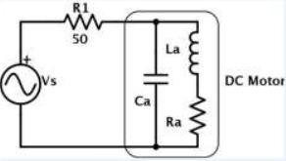
- Tabularize the results with ten equally spaced points per decade (log scale).
- From the obtained data, determine the inductance ‘L’ of the motor.
Tasks: Part II
- Derive the transfer function of a DC motor for angular speed
- Find ‘KDC’ from the data collected in laboratory exercise one.
  - $K_{DC}=\frac{ω}{V_{avg}}$
- Find ‘K’ and ‘B’
  - $Ki-Bω=0$
    - Measure current ‘i’ and motor speed ‘𝜔’ at fifty percent duty cycle.
  - $K_{DC}=\frac{K}{RB+K^{2}}$
- Find ‘$τ_{m}$’ and ‘J’
  - ‘τm’ is the time for the feedback voltage to reach 63.2% of the final value from a step input.
    - Apply step input and plot the response on oscilloscope
    - Find 63.2% of total rise and measure the time
  - $s=-\frac{1}{τ_{m}}$
  - $s=-\frac{R_{a}B+K^{2}}{R_{a}J}$
- Use the provided Simulink Model (Blackboard) to simulate the system
  - Explore the subsystem levels of the model and understand how these work
  - Add the appropriate source (Voltage) and sink (Speed) to run the simulation
  - Use a Matlab script to update the variables in the Matlab workspace.
  - After all, variables are solved and in the workspace run the simulation.
  - Perform a source voltage sweep from 0-100% similar to what you did in Laboratory exercise one and plot the average motor voltage vs. motor speed (rad/s).
  - Compare the simulated ‘KDC’ with the actual and calculate the percent error.
  - Determine the simulated ‘τm’ and the corresponding percent error.

Background
- Permanent DC Motor
A permanent magnet DC (PMDC) motor has poles made of permanent magnets. It consists of:
- A permanent magnetic structure that is static
- The field produces a magnetic medium
- An armature which rotates
- The armature produces voltage and torque under the action of the magnetic field
In the design of permanent-magnet DC motors, the flux of a PMDC motor is fixed. And the only way of speed control for PMDC motors is armature voltage control.
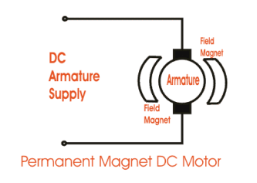
The motor is characterized by mechanical and electrical elements. The motor receives an electrical signal and produces a mechanical force.

  - Electrical Characteristics
$i_{a}\left(t\right):$ armature current is the flow of electricity through the motor.
$R_{a}:$ armature resistance is the impedance of the motor.
$L_{a}:$ armature inductance is the electrical energy stored in the motor.
$e_{b}\left(t\right):$ back emf is the voltage that occurs in the motors from the relative motion between the stator windings and the rotor’s magnetic field.
$e_{a}\left(t\right):$ applied voltage to the motor.
  - Mechanical Characteristics
$T_{m}\left(t\right):$ motor torque is the amount of rotational force produced by the motor.
$T_{L}\left(t\right):$: load torque is the amount of force required for the motor to function.
$q_{m}\left(t\right):$ angular displacement is the angle in which the motor rotates.
$ω_{m}\left(t\right):$ angular velocity is the speed at which the motor rotates.
$J_{m}:$ motor inertia is the resistance of the motor to a change of rotational speed.
$B_{m}:$ viscous friction is the motors resistive force between surfaces.

- Motor Model
The motor model will give a better understanding of the motor. This will allow a design for a controller to be built for this particular system. It will also determine any necessary gain constants mathematically. The identification process of the motor model allows for simulation of the system, so that control parameters can be tuned and repeatedly tested if necessary.
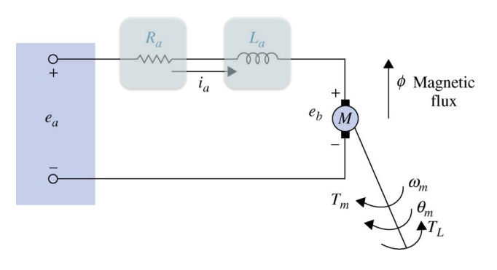
  - Electrical
The electrical part of the motor model can be described under Kirchhoff’s Voltage Law. The summation of voltage potentials in the closed-loop system will equal zero.
$$0=\sum_{i=0}^{I}{v_{i}\left(t\right)}$$
$$0=e_{a}\left(t\right)-V_{Ra}\left(t\right)-V_{La}\left(t\right)-e_{b}\left(t\right)$$
$$0=e_{a}\left(t\right)-R_{a}i_{a}\left(t\right)-L_{a}\frac{di_{a}\left(t\right)}{dt}-e_{b}\left(t\right)$$
  - Mechanical
The mechanical part of the motor model can be described under Newton’s Law. The speed of the motor's armature is a summation of all the forces applied to the armature.
$$J_{m}α\left(t\right)=\sum_{i=0}^{I}{T_{i}\left(t\right)}$$
$$J_{m}α\left(t\right)=T_{m}\left(t\right)-T_{B}\left(t\right)-T_{L}\left(t\right)$$
$$J_{m}α\left(t\right)=T_{m}\left(t\right)-B_{m}ω_{m}\left(t\right)-T_{L}\left(t\right)$$
$$J_{m}ϖ_{m}\left(t\right)=T_{m}\left(t\right)-B_{m}ω_{m}\left(t\right)-T_{L}\left(t\right)$$
  - Combination
Due to the linearity of a Brushed DC Motor, voltage is proportional to speed ($K_{b}$ induced EMF constant).
$$e_{b}=K_{b}ω_{m}$$
Torque is proportional to current ($K_{t}$ torque constant),
$$T_{m}=K_{t}i_{a}$$
and assuming negligible losses
$P_{m}=ω_{m}T_{m}=e_{b}i_{a}$
$$ω_{m}K_{t}i_{a}=K_{b}ω_{m}i_{a}$$
$$K_{t}=K_{b}=K$$
Where motor Gain Constant is (K).
- Transfer Function
The correlation between the electrical input for the mechanical output can be defined in a transfer function. This is done by taking the Laplace transform of each part and connecting the two.
  - Electrical
$$0=e_{a}\left(t\right)-R_{a}i_{a}\left(t\right)-L_{a}\frac{di_{a}\left(t\right)}{dt}-e_{b}\left(t\right)$$
$$L_{a}\frac{di_{a}\left(t\right)}{dt}+R_{a}i_{a}\left(t\right)=e_{a}\left(t\right)-e_{b}\left(t\right)$$
Take Laplace transform
$$L_{a}sI_{a}\left(s\right)+R_{a}I_{a}\left(s\right)=E_{a}\left(s\right)-E_{b}\left(s\right)$$
$$\left(L_{a}s+R_{a}\right)I_{a}\left(s\right)=E_{a}\left(s\right)-E_{b}\left(s\right)$$
$$\frac{I_{a}\left(s\right)}{E_{a}\left(s\right)-E_{b}\left(s\right)}=\frac{1}{\left(L_{a}s+R_{a}\right)}$$
  - Mechanical
$J_{m}sϖ_{m}\left(t\right)=T_{m}\left(t\right)-B_{m}ω_{m}\left(t\right)-T_{L}\left(t\right)$
$$J_{m}sϖ_{m}\left(t\right)+B_{m}ω_{m}\left(t\right)=T_{m}\left(t\right)-T_{L}\left(t\right)$$
Take Laplace transform
$$J_{m}sΩ_{m}\left(s\right)+B_{m}Ω_{m}\left(s\right)=T_{m}\left(s\right)-T_{L}\left(s\right)$$
$$\left(J_{m}s+B_{m}\right)Ω_{m}\left(s\right)=T_{m}\left(s\right)-T_{L}\left(s\right)$$
$\frac{Ω_{m}\left(s\right)}{T_{m}\left(s\right)-T_{L}\left(s\right)}=\frac{1}{\left(J_{m}s+B_{m}\right)}$
Simplify 𝐵𝑚 as B
$\frac{Ω_{m}\left(s\right)}{T_{m}\left(s\right)-T_{L}\left(s\right)}=\frac{1}{\left(J_{m}s+B\right)}$
  - Connection
$$e_{b}=K_{b}ω_{m}→E_{b}=KΩ_{m}$$
$$T_{m}=K_{t}i_{a}→T_{m}=KI_{a}$$
$$θ_{m}=\frac{1}{s}Ω_{m}$$
  - Overall
$$\frac{Ω\left(s\right)}{E_{a}\left(s\right)}=\frac{G}{1+GH}$$

$$\frac{Ω\left(s\right)}{E_{a}\left(s\right)}=\frac{\frac{K}{\left(sL_{a}+R_{a}\right)\left(sJ+B\right)}}{1+\left(\frac{K}{\left(sL_{a}+R_{a}\right)\left(sJ+B\right)}\right)K}$$
$$\frac{Ω\left(s\right)}{E_{a}\left(s\right)}=\frac{K}{JL_{a}s^{2}+\left(JR_{a}+BL_{a}\right)s+R_{a}B+K^{2}}$$
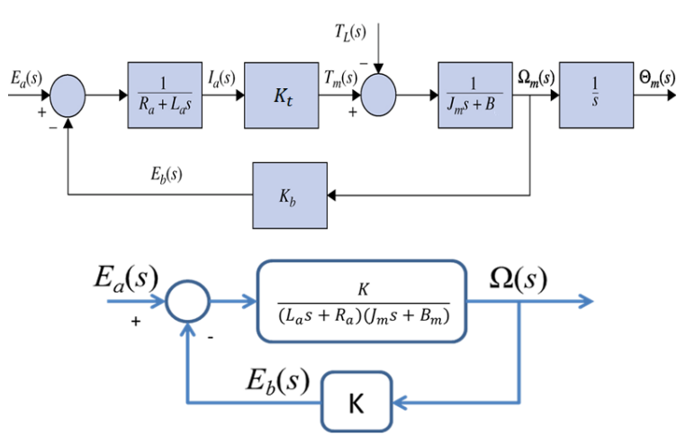
- Impedance and Reactance
Impedance of the winding is a vector summation of the DC resistance and the reactance of the winding.
$$Z_{a}^{2}=R_{a}^{2}+X_{a}^{2}$$
$$Z_{a}=\sqrt{R_{a}^{2}+X_{a}^{2}}$$
The DC resistance (R) of the motor is the opposition of current when direct current is applied. Reactance(X) of the motor is the opposition of current when alternating current is applied. The motor utilized has a capacitive reactance and an inductive reactance.
$$X_{L}=2πfL$$
$$X_{C}=\frac{1}{2πfC}$$
This means at low frequencies the motor’s reactance is inductive, at high frequencies it is capacitive, and at medium frequencies it is both.
  - Resonance Frequency
The point when the reactance from the capacitance and inductance overlap is considered the resonance frequency of the motor. At this point the;
$$X_{C}=X_{L}$$
The motor capacitive component is parallel with the inductive component.
$$X_{a}=X_{L}\left|\right|X_{C}=\frac{X_{L}X_{C}}{X_{L}+X_{C}}$$
This causes a max phase shift of 90 degrees.

Calculations
Kdc = 69.279
L = 318 nH;
R = 2.93;
K = .0086;
J = 1.3517E-11;
B = 1.7149E-5;
T = 400 ns

Code
No code changes were made to the controller. Simulations were done utilizing Simlink to confirm experimental findings. As well as MatLab to help with calculations.
Simlink
%%Close figures and clear command window
close all;
clear;
clc;
%%Enter experimentally determined motor parameters
L = 318E-9;
R = 2.93;
K = .0086;
J = 1.3517E-11;
B = 1.7149E-5;
D = 0.5;
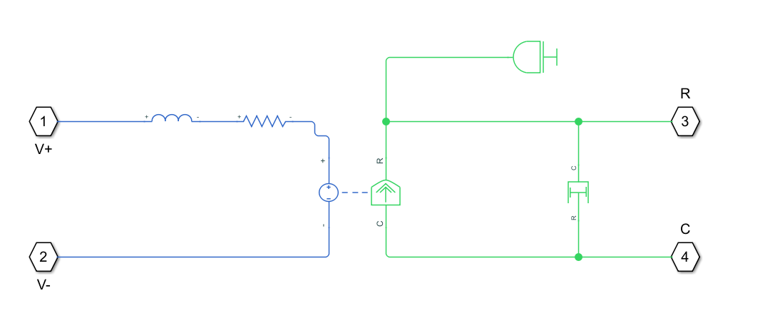

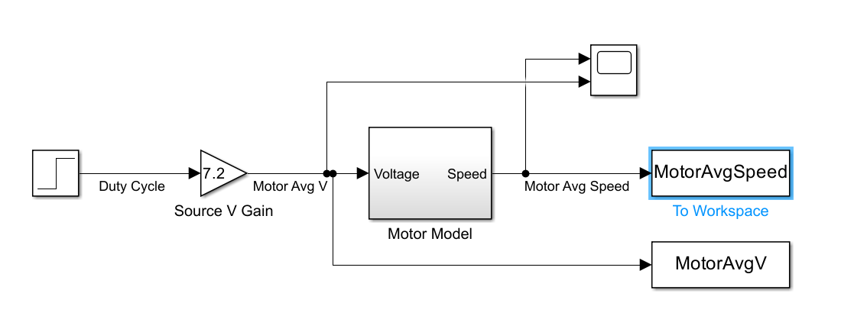
Parameters
%Parameters for Lab 2
clc;
clear all;
close all;
%K_dc
K_dc=69.279
%K
omega=350;%Motor Speed at 50% Duty Cycle
i=0.7; %Motor Current
R=2.93 %Measured Armature Resistance
K=(1/K_dc)-((i*R)/omega)
%B
B=(K*i)/omega
%J
t=24E-9; %time for feedback voltage to reach 63.2% of the final value
s=-(1/t)
J=(-1*(B/s))-(K^2/(s*R))
%L
L=318.08E-9 %Measured inductance
%Percent Error
%act=1.6E-6;
%mea=40E-6;
%n=((act-mea)/mea)*100

Results
- Part I
  - Coil Resistance
Meter Error for resistance = 0.2Ω
Test # | Left Motor Resistance (Ohm) | Right Motor Resistance (Ohms) | Actual Left Motor Resistance (Ohms) | Actual Right Motor Resistance (Ohms)
1 | 1.7 | 6.0 | 1.5 | 5.8
2 | 2.4 | 3.0 | 2.2 | 2.8
3 | 1.6 | 3.3 | 1.4 | 3.1
4 | 1.9 | 4.3 | 1.7 | 4.1
5 | 2.2 | 3.0 | 2 | 2.8
6 | 1.5 | 1.6 | 1.3 | 1.4
7 | 1.7 | 2.7 | 1.5 | 2.5
8 | 1.9 | 2.0 | 1.7 | 1.8
9 | 2.1 | 1.8 | 1.9 | 1.6
10 | 1.3 | 3.6 | 1.1 | 3.4
AVG | 1.83 | 3.13 | 1.63 | 2.93
  - Frequency Sweep
Frequency | Source Voltage (mV) | Resistor Voltage (mV) | Motor Voltage (mV) | Phase Shift (deg) | Motor Current (mA) | Motor Impedance (Ohms) | Motor Inductance (nH)
10 | 130.00 | 118.27 | 11.73 | 0.00 | 2.32 | 5.06 | 131.24
12 | 130.00 | 121.45 | 8.55 | 0.00 | 2.38 | 3.59 | 54.11
15 | 130.00 | 121.81 | 8.19 | 0.00 | 2.39 | 3.43 | 38.03
18 | 130.00 | 120.70 | 9.30 | 0.00 | 2.37 | 3.93 | 45.69
22 | 130.00 | 121.01 | 8.99 | 0.00 | 2.37 | 3.79 | 34.31
27 | 130.00 | 121.17 | 8.83 | 0.00 | 2.38 | 3.72 | 26.76
33 | 130.00 | 121.42 | 8.58 | 0.00 | 2.38 | 3.60 | 20.10
41 | 130.00 | 121.83 | 8.17 | 0.00 | 2.39 | 3.42 | 13.83
50 | 130.00 | 121.94 | 8.07 | 0.00 | 2.39 | 3.37 | 10.72
61 | 130.00 | 120.53 | 9.47 | 0.02 | 2.36 | 4.01 | 14.35
74 | 130.00 | 120.84 | 9.16 | 0.05 | 2.37 | 3.87 | 10.83
90 | 130.00 | 120.29 | 9.71 | 0.10 | 2.36 | 4.12 | 10.18
111 | 130.00 | 120.77 | 9.23 | 0.16 | 2.37 | 3.90 | 7.41
135 | 130.00 | 120.53 | 9.47 | 0.24 | 2.36 | 4.01 | 6.45
165 | 130.00 | 120.58 | 9.43 | 0.36 | 2.36 | 3.99 | 5.22
202 | 130.00 | 120.72 | 9.29 | 0.51 | 2.37 | 3.92 | 4.12
246 | 130.00 | 120.44 | 9.56 | 0.71 | 2.36 | 4.05 | 3.61
301 | 130.00 | 120.65 | 9.35 | 0.97 | 2.37 | 3.95 | 2.81
367 | 130.00 | 120.99 | 9.01 | 1.32 | 2.37 | 3.80 | 2.09
449 | 130.00 | 120.49 | 9.51 | 3.23 | 2.36 | 4.03 | 1.96
548 | 130.00 | 122.26 | 7.74 | 5.92 | 2.40 | 3.23 | 0.79
670 | 130.00 | 121.21 | 8.79 | 9.65 | 2.38 | 3.70 | 1.07
819 | 130.00 | 120.80 | 9.20 | 14.73 | 2.37 | 3.88 | 0.99
1000 | 130.00 | 120.86 | 9.14 | 22.28 | 2.37 | 3.86 | 0.80
1222 | 130.00 | 120.19 | 9.82 | 16.67 | 2.36 | 4.16 | 0.77
1493 | 130.00 | 120.62 | 9.38 | 24.19 | 2.37 | 3.97 | 0.57
1823 | 130.00 | 119.41 | 10.59 | 21.66 | 2.34 | 4.52 | 0.60
2228 | 130.00 | 119.05 | 10.95 | 32.88 | 2.33 | 4.69 | 0.52
2721 | 130.00 | 118.17 | 11.83 | 37.03 | 2.32 | 5.11 | 0.49
3325 | 130.00 | 116.82 | 13.18 | 37.22 | 2.29 | 5.75 | 0.47
4062 | 130.00 | 115.87 | 14.13 | 36.12 | 2.27 | 6.22 | 0.43
4962 | 130.00 | 114.30 | 15.70 | 40.55 | 2.24 | 7.01 | 0.41
6062 | 130.00 | 115.86 | 14.14 | 41.25 | 2.27 | 6.22 | 0.29
7406 | 130.00 | 113.00 | 17.00 | 39.72 | 2.22 | 7.67 | 0.30
9047 | 130.00 | 109.58 | 20.42 | 44.62 | 2.15 | 9.50 | 0.32
11053 | 130.00 | 106.53 | 23.47 | 38.88 | 2.09 | 11.24 | 0.31
13503 | 130.00 | 99.74 | 30.26 | 37.33 | 1.96 | 15.47 | 0.36
16496 | 130.00 | 96.10 | 33.90 | 38.48 | 1.88 | 17.99 | 0.34
20153 | 130.00 | 91.94 | 38.06 | 32.50 | 1.80 | 21.11 | 0.33
24621 | 130.00 | 88.27 | 41.73 | 29.07 | 1.73 | 24.11 | 0.31
30079 | 130.00 | 84.28 | 45.72 | 26.85 | 1.65 | 27.67 | 0.29
36747 | 130.00 | 85.52 | 44.48 | 26.85 | 1.68 | 26.53 | 0.23
44893 | 130.00 | 80.77 | 49.23 | 22.46 | 1.58 | 31.08 | 0.22
54844 | 130.00 | 74.96 | 55.04 | 22.71 | 1.47 | 37.45 | 0.22
67002 | 130.00 | 68.95 | 61.05 | 18.72 | 1.35 | 45.16 | 0.21
81855 | 130.00 | 63.50 | 66.50 | 21.89 | 1.25 | 53.41 | 0.21
100000 | 130.00 | 57.16 | 72.84 | 15.23 | 1.12 | 64.99 | 0.21
122168 | 130.00 | 55.36 | 74.64 | 11.57 | 1.09 | 68.76 | 0.18
149250 | 130.00 | 51.01 | 78.99 | 10.69 | 1.00 | 78.97 | 0.17
182335 | 130.00 | 39.13 | 90.87 | 11.22 | 0.77 | 118.44 | 0.21
222754 | 130.00 | 39.66 | 90.34 | 7.35 | 0.78 | 116.17 | 0.17
272134 | 130.00 | 27.30 | 102.70 | 8.05 | 0.54 | 191.86 | 0.22
332460 | 130.00 | 27.00 | 103.00 | 5.48 | 0.53 | 194.56 | 0.19
406159 | 130.00 | 25.50 | 104.50 | 4.91 | 0.50 | 209.00 | 0.16
496195 | 130.00 | 22.30 | 107.70 | 4.84 | 0.44 | 246.31 | 0.16
606190 | 130.00 | 12.90 | 117.10 | 0.00 | 0.25 | 462.95 | 0.24
740568 | 130.00 | 18.20 | 111.80 | 0.00 | 0.36 | 313.29 | 0.13
904736 | 130.00 | 9.00 | 121.00 | 0.00 | 0.18 | 685.67 | 0.24
1105295 | 130.00 | 13.10 | 116.90 | 0.00 | 0.26 | 455.11 | 0.13
1350314 | 130.00 | 9.30 | 120.70 | 0.00 | 0.18 | 661.90 | 0.16
1649648 | 130.00 | 7.50 | 122.50 | 0.00 | 0.15 | 833.00 | 0.16
2015338 | 130.00 | 5.70 | 124.30 | 0.00 | 0.11 | 1112.16 | 0.18
2462092 | 130.00 | 1.10 | 128.90 | 0.00 | 0.02 | 5976.27 | 0.77
3007883 | 130.00 | -3.30 | 133.30 | 0.00 | -0.06 | -2060.09 | 0.22
3674662 | 130.00 | 4.10 | 125.90 | 0.00 | 0.08 | 1566.07 | 0.14
4489251 | 130.00 | 3.00 | 127.00 | -7.76 | 0.06 | 2159.00 | 0.15
5000000 | 130.00 | -2.80 | 132.80 | -5.76 | -0.05 | -2418.86 | 0.15
  - Oscilloscope Images
    - Left Motor
1Hz 28Hz
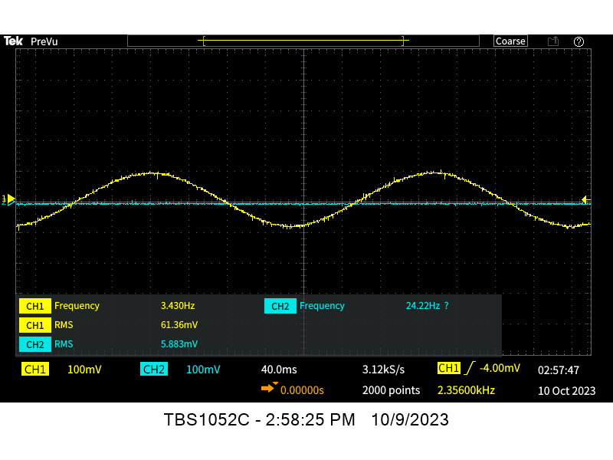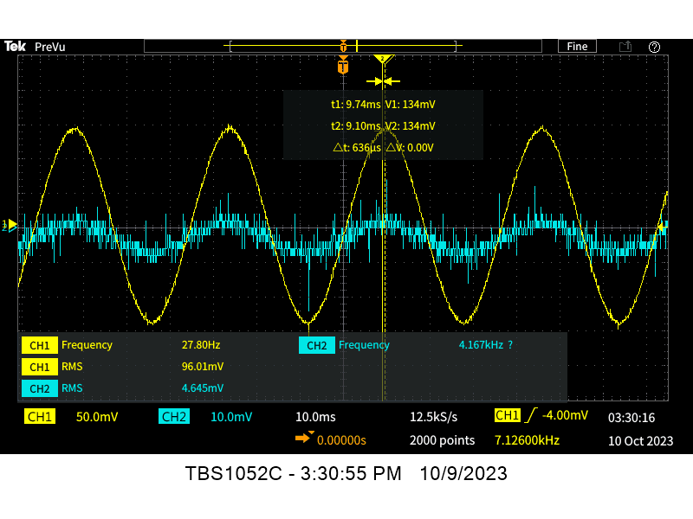
154Hz 855Hz
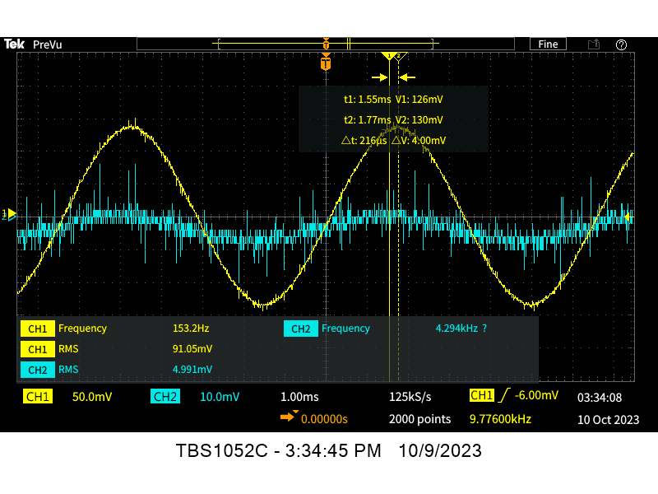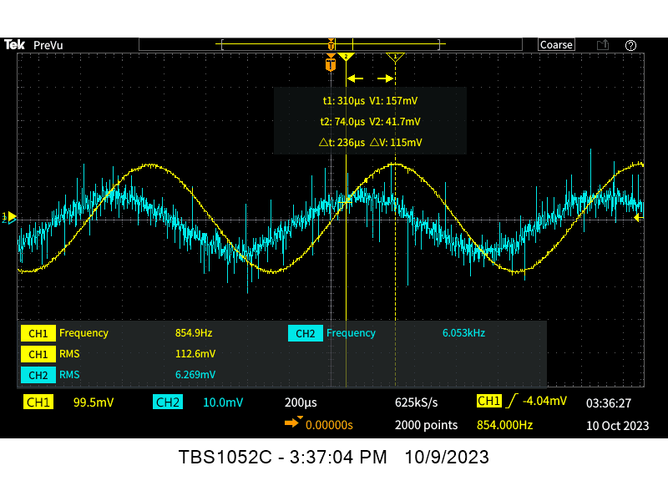

4745Hz 26kHz
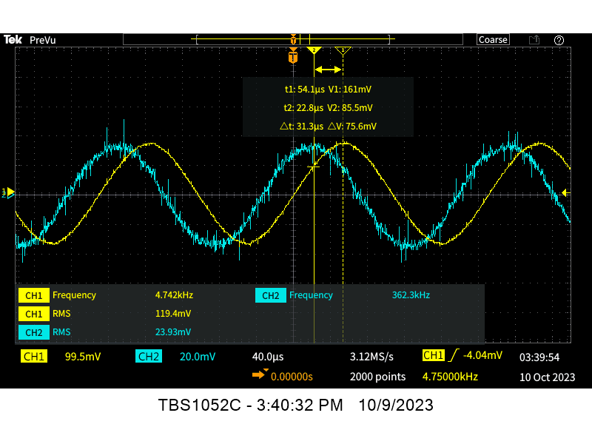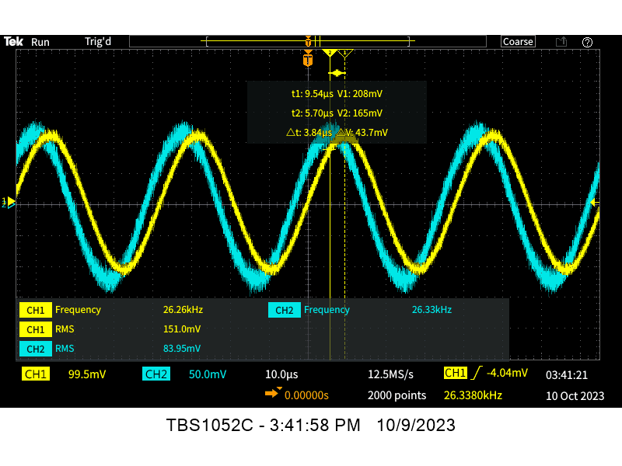
146kHz 811kHz
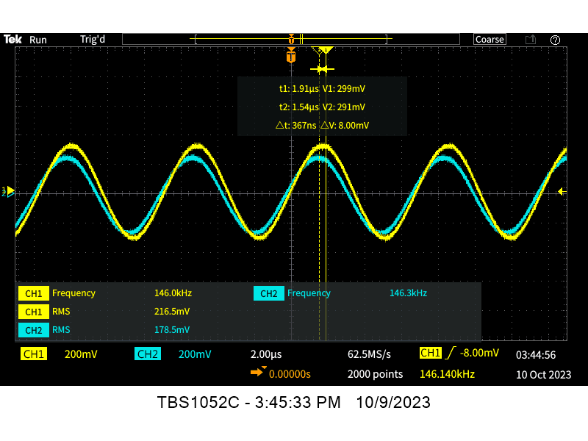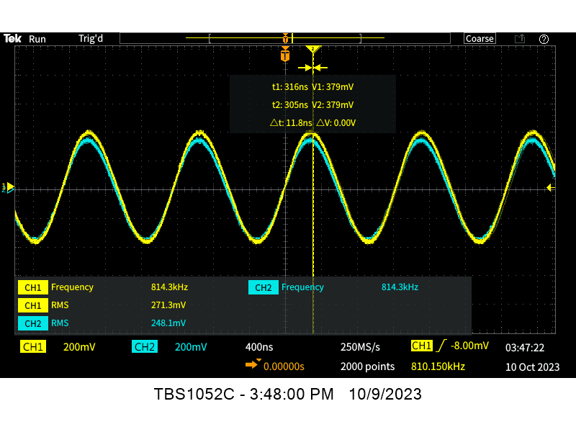
4MHz 5MHz
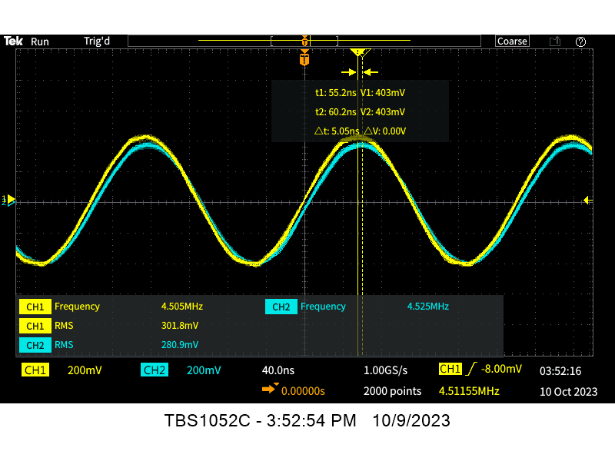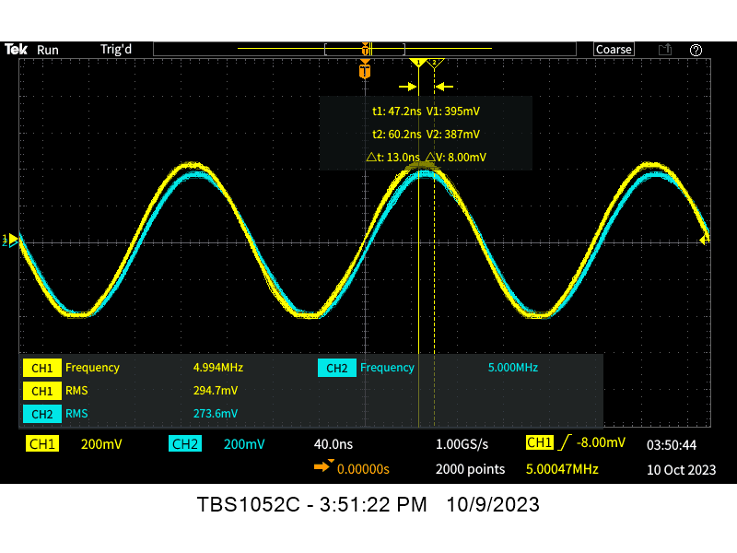
    - Right Motor
1Hz 28Hz
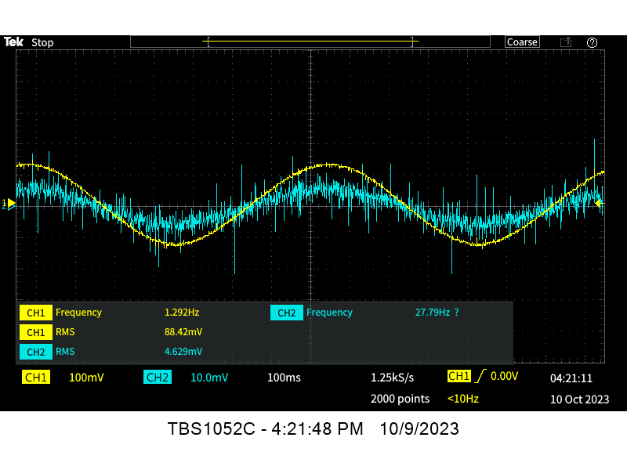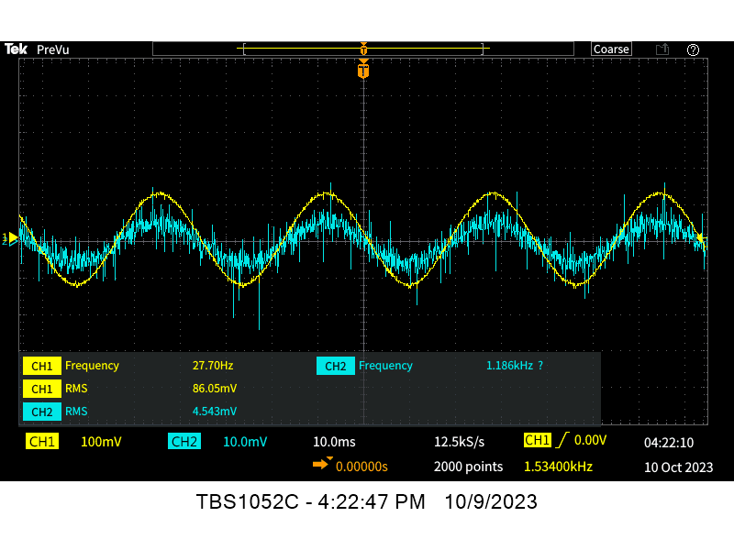
154Hz 855Hz
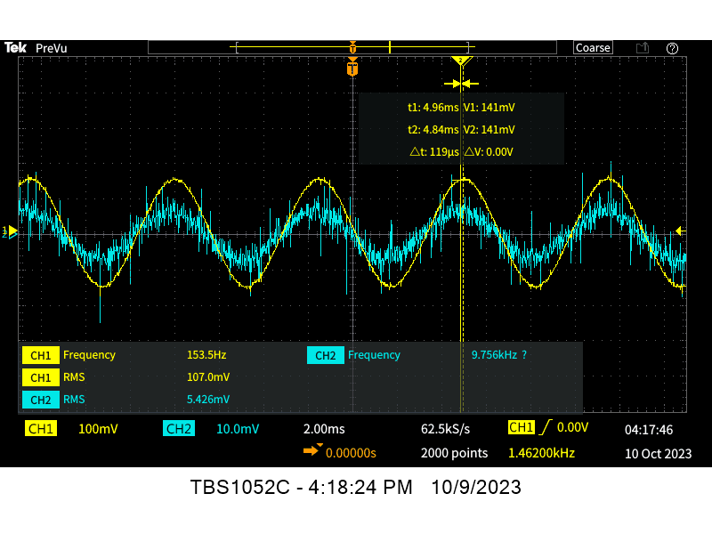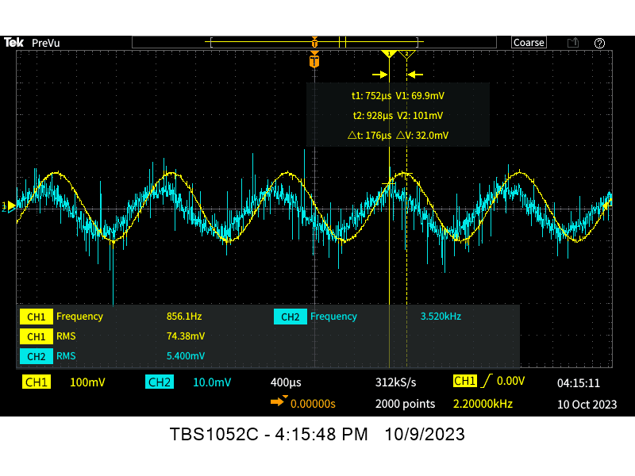
4745Hz 26kHz
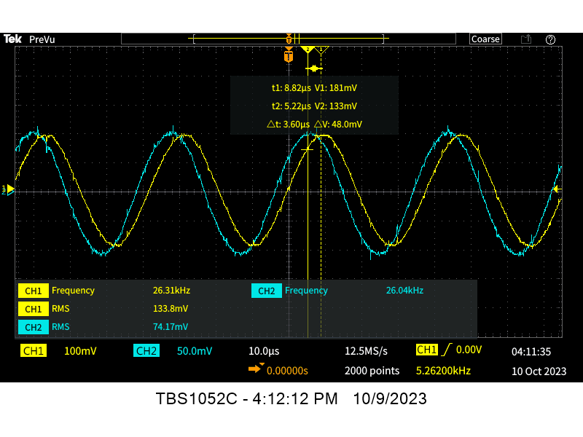
146kHz 811kHz
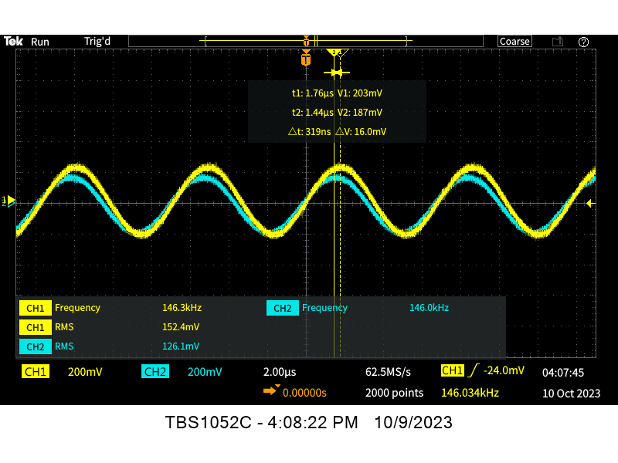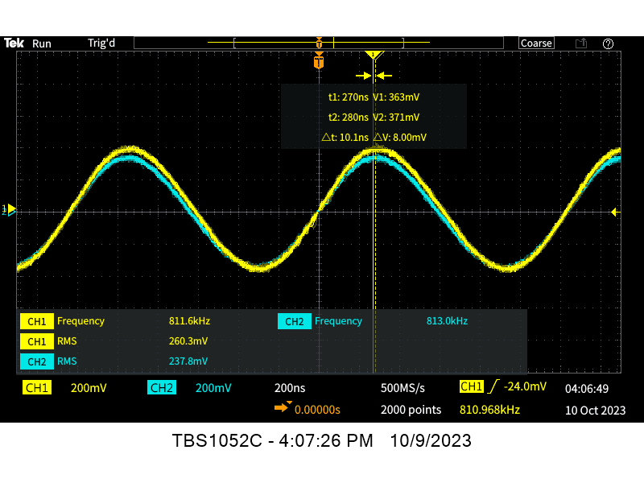
4MHz 5MHz
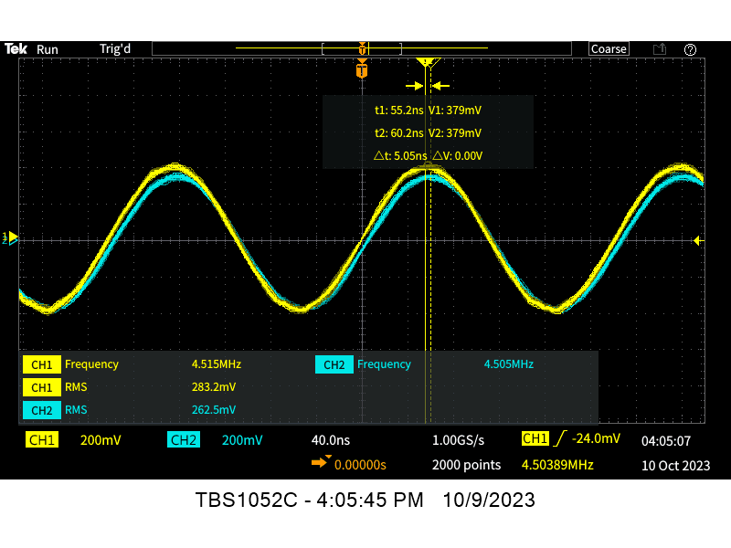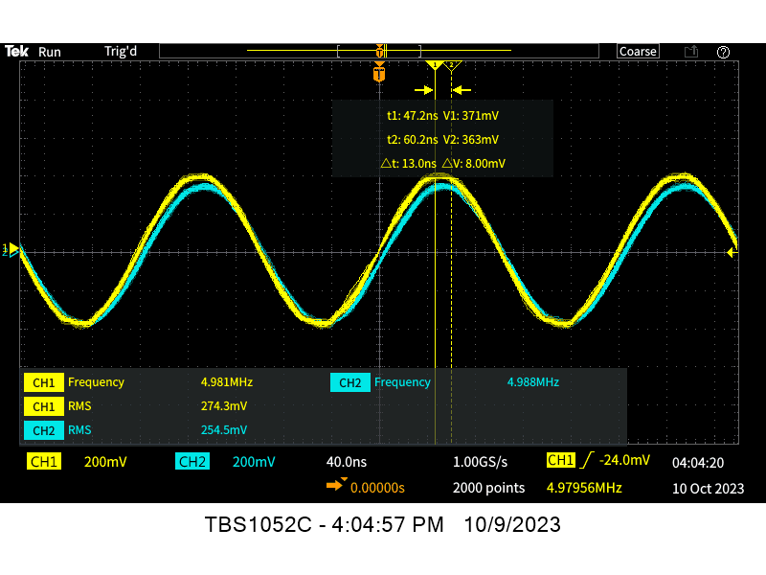
    - $T_{m}$
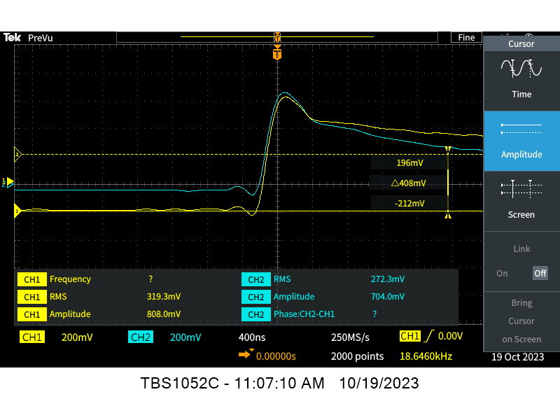
- Part II
Tm
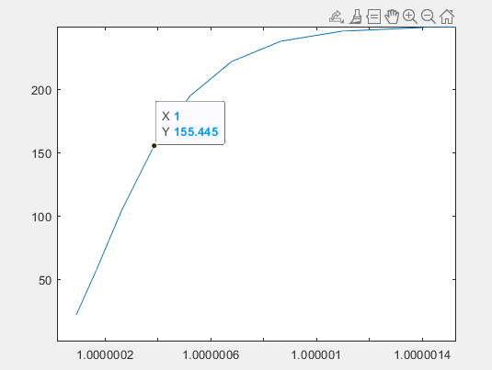

Measured Time Constant = 380ns
Simulated Time Constant = 380ns
Percent Error = 0

Motor Voltage vs. Speed
Simulated Actual
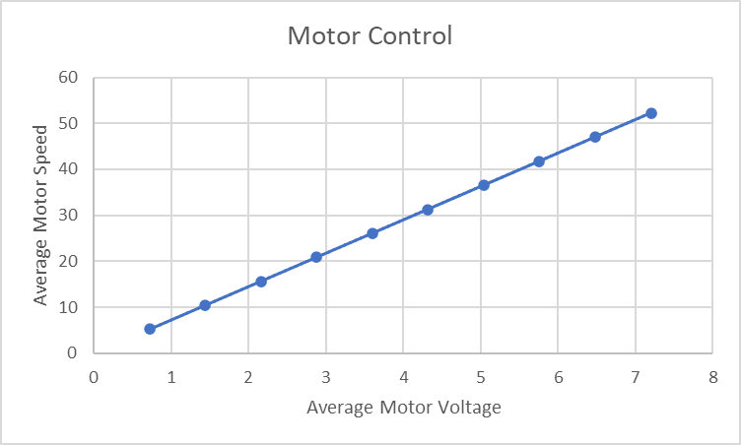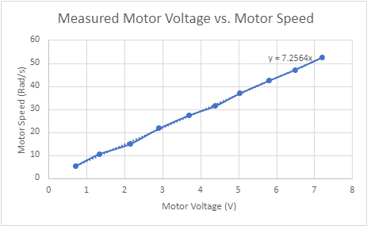

Measured $K_{dc}$ = 7.256 rad/s
Simulated $K_{dc}$ = 7.248 rad/s
Percent Error = 0.11%

Problems Encountered
- Knowing how to get the resonance frequency from frequency sweep
- Recording data for the frequency sweep to get inductance
- Understanding the correlation between state equations
- Implementing the Simlink model

Questions
- Why do we need to take multiple measurements of the winding resistance?
  - Why do we need to account for the DMM lead resistance in the measurement?
Answer: The DMM has an internal lead resistance that is small but does affect the motor resistance measurement.
  - Why does the resistance change with respect to the shaft position?
Answer: The resistance varies depending on the location of the shaft because the gap between the brushes and commutator is not fixed.
  - Over the lifetime of the motor, what is expected to happen to the resistance? Why?
Answer: The resistance is expected to increase due to the wearing of the brush, which creates a larger gap.
- Why perform a frequency sweep?
  - What assumption(s) can be verified by this test?
Answer: A frequency sweep will give a visual representation of the phase shift as a change in frequency. Once the phase shift reaches 90 degrees an assumption can be made that the reactance of the capacitance and inductance is equal.
- What frequency is the inductance of the motor measured at and why?
Answer: The inductance of the motor is measured at resonance frequency. This is because we do not know the capacitance or inductance. At resonance frequency we can assume the capacitance and inductance is the same, which allows for simplification in the calculations by removing unknown variables.

Requirements
- Check-off requirements:
  - Completion of measured motor parameters
  - Tabularized chart of frequency sweep
  - Description of derivation and identification processes and main results
  - Completion and demonstration of motor simulation
  - Transfer function coefficients for the DC model must be within acceptable range (≤1%)
  - Comparison of Part 1 experimental results with the simulated model in Simulink
- Check-off report: (Group)
  - Refer to rubric and template from Blackboard
  - Be sure to include:
    - Description of identification process
    - Description of the frequency sweep.
    - Derivation of Transfer Function
    - Description of Transfer Function Coefficients
    - Results presentation (include o-scope images, measurement records, etc.)
    - Results analysis and discussion
    - Hardware schematic (using PSpice, TinyCAD, EAGLE, etc.)
    - Problem-solving (describe problems you encountered and how you solved them)

Time Sheet
Name | Date | Start Time | End Time | Total Time Spent | Tasks / Notes
Nicholas George | 10/08/2023 | 20:00 | 21:30 | 1 Hr. 30 Min. | Lab Notebook 02 documentation
Team | 10/09/2023 | 13:30 | 17:00 | 3 Hr. 30 Min. | Lab 02 Measurements
Team | 10/14/2023 | 09:00 | 12:00 | 3 Hr. 0 Min. | Lab 02 Measurements
Team | 10/16/2023 | 13:30 | 17:00 | 3 Hr. 30 Min. | Lab 02 Measurements
Team | 10/19/2023 | 09:00 | 12:00 | 3 Hr. 0 Min. | Lab 02 Calculations
Team | 10/20/2023 | 09:00 | 12:00 | 3 Hr. 0 Min. | Lab 02 Calculations
Team | 10/23/2023 | 13:30 | 17:00 | 3 Hr. 30 Min. | Lab 02 Simulations
Team | 10/23/2023 | 11:30 | 17:00 | 6 Hr. 30 Min. | Adjusting Data from Lab01

Lab 03:
Motor Control (Group A)

General Objectives
- Design a closed-loop DC motor controller and determine necessary coefficient values
- Simulate open vs. closed-loop system continuous time response using MATLAB
- Determine system stability by its transfer function using the Nyquist stability criterion
  - Simulate the discretized closed-loop system model using Simulink software; compare with continuous time MATLAB results
- Implementation of micro-controller based closed-loop DC motor control
- Testing and validation of the complete control system

Main Specifications
- Motor voltage: 7.2V
- Switching frequency: ≥20 kHz
- Speed range: 0-100% (Design to match the DC motor’s rated voltage!!!)
- External voltage (speed) reference: 0-3.3V
- Feedback: Incremental Encoder

Tasks: Motor Control Design and Simulation
- Research data sheets for components and understand why they are used (their ratings)
- Determine appropriate gains (conversion factors) present in your system (i.e. gear ratio, frequency-to-voltage, ADC, etc.) put into Matlab
  - The ADC gain can be noted as a normalized value due to mbed software.
  - Normally you would need the associated bit value representation for the Analog to Digital Converter (ADC) and the Digital to Analog Converter (DAC).
- UNDERSTAND the provided Matlab code and each plotted figure, explanations will be expected.
  - You may need to alter some code in order to get more effective plots.
  - Make note of the resulting ‘kp’ and ‘ki’ values in your lab notebook.
  - Determine stability from bode plot
  - Determine stability from Nyquist plot
- Build system model in Simulink including gains, the feedback loop, and a discretized PI controller similar to the schematic below.
  - For sample time ‘ti’ and the controller’s unit delay use 1 kHz for this lab.
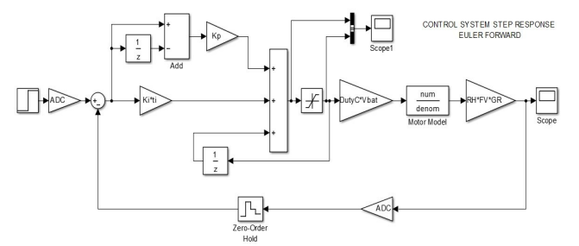
- Plot step response using a three channel scope in Simulink.
  - Step Input
  - Controller Output
  - System Output
- Inject disturbances to the system and insure rejection from controller.
  - Change in supply voltage. ELCT 302 – 001 Laboratory Worksheet Real Time Systems Laboratory 6
  - Change in motor load.
    - Increase and decrease the load, vary the damping coefficient ‘B’ during the simulation using a switch or math logic.
  - Controller Saturation.
    - When the controller exceeds the physical limitation.
    - Be able to explain the concept and show in a plot.
- Determine if the controller can respond correctly to the Supply Voltage Range of the selected battery.
  - Vary the ‘Vbat’ constant from the upper charge limit to the lower charge limit.
- Determine the loading range of the controller before saturation occurs.
- Tabularize results
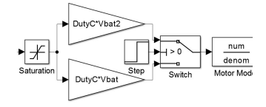
Tasks: Controller Implementation
- Using mbed, program the microcontroller and test closed-loop controller operation.
  - Use Euler Forward integration method to implement the following PI controller in the discrete domain.
  - Use the Simulink schematic from Lab 2. as a guide.
  - Use a software interrupt in order to sample the current speed and update the PWM duty cycle at a predetermined interval. Call this interval interrupt time ‘TI’.
  - Constants can be set as compiler defines at the top of code or in ‘.h’ files:
#define TI 0.001 %1kHz sample time
#define KP 1.0f %Proportional Gain
#define KI 1.0f %Integral Gain
  - The PI controller can be represented as follows:
$$u\left(t\right) = k_{p}e\left(t\right) + k_{i} \int_{0}^{t}{e\left(t\right)dt} → u\left(k\right) = k_{p}e\left(k\right) + k_{i} \sum_{i=0}^{k}{e\left(i\right)}*ti$$
  - The PI controller with Eular forward approximation can be implemented in code as:
errorArea(i)= TI*error(i) + errorArea(i-1);
controllerOutput(i) = KP*error(i)+ KI*errorArea(i);
- Input a step signal to the system and measure the dynamic response
  - Use the microcontroller to create the step signal.
  - Compare results to both MATLAB and Simulink. Explain differences (% error).
  - Fill out the table started in Tasks: Motor Control Design and Simulation
- Measure your system’s no-load bandwidth.
  - Bandwidth of the system to an input sine waveform with the tire off the ground (“No Load”).
- Input the following waveforms in place of the potentiometer voltage as a reference signal and explain the control performance.
  - Triangle waveform
  - Sinusoidal waveform

Background

Calculations

Code

Results
Gains
RH = 16/(2*pi); %insert value here %Rad to Hz
GR = (1/7.5); %insert value here %Gear Ratio
FV = 0.0022; %insert value here %Frequency to voltage
ADC = (1/3.3); %insert value here %ADC conversion voltage to ADC#
DutyC = 1; %insert value here %Conversion from ADC# to Duty cycle
Vbat = 7.2; %insert value here %Gain of the battery
Feedback = RH*FV*ADC; %Feedback path gain
Gforward = GR*Gmotor*DutyC*Feedback*Vbat; %Forward path gain

WC = 30 rad/sec
WM = 60 degrees

Kp = 23.725966576570650
Ki = 3.331304132907478e+03

Bode
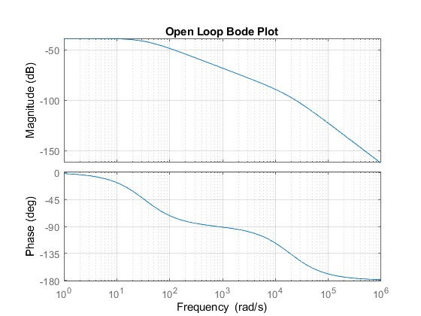

Bode No Feedback
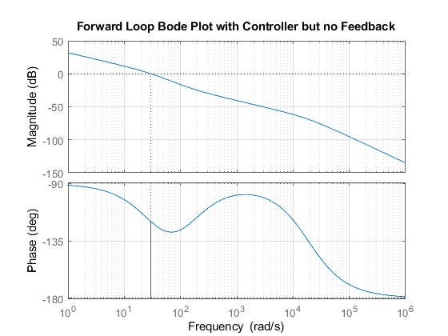

Nyquist
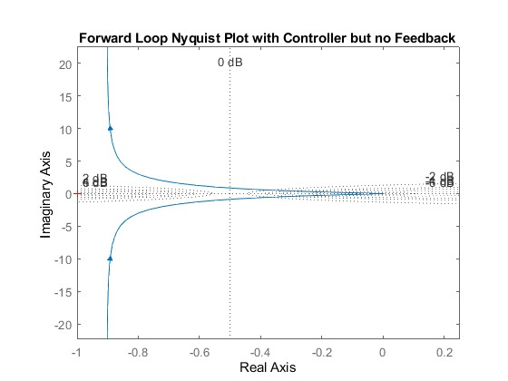

Closed Loop Step Response
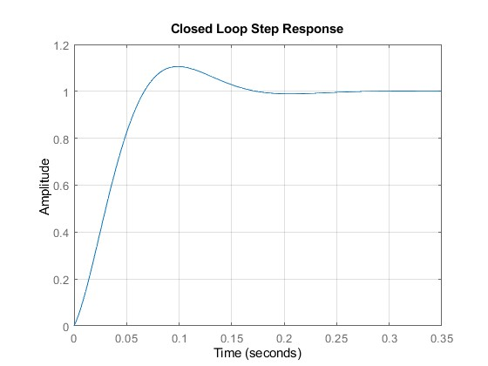

SimLink 01
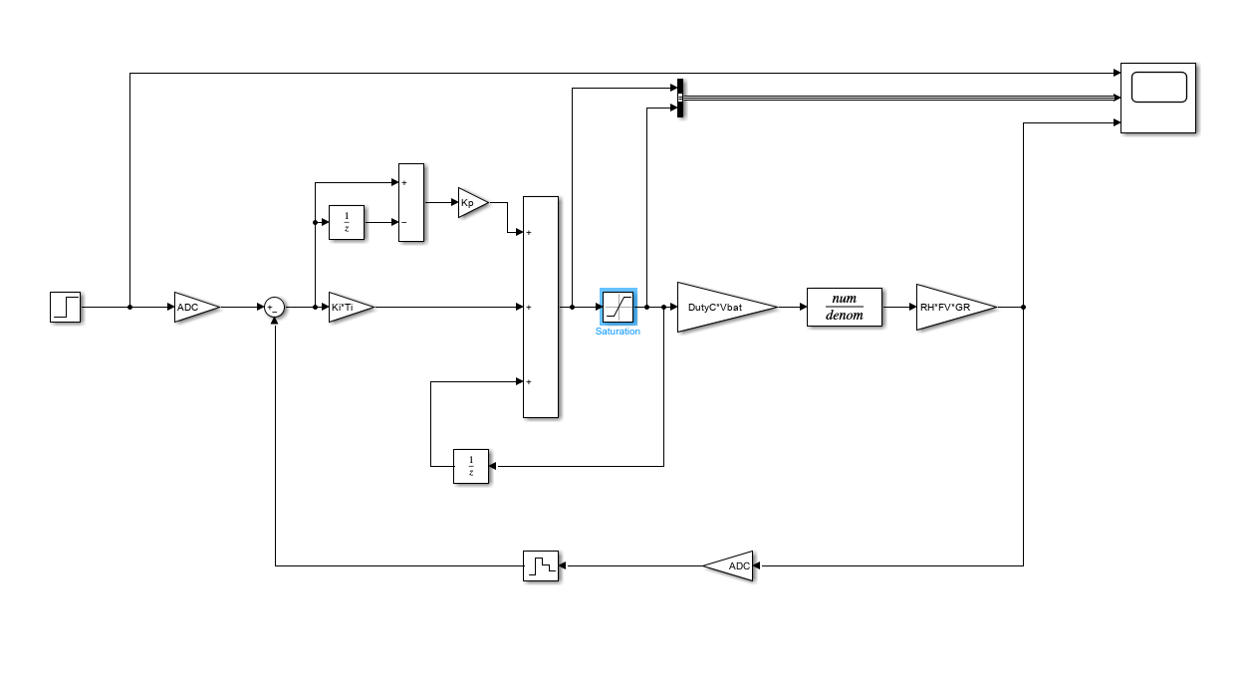

Scope Image (Step / Controller / System Outputs)
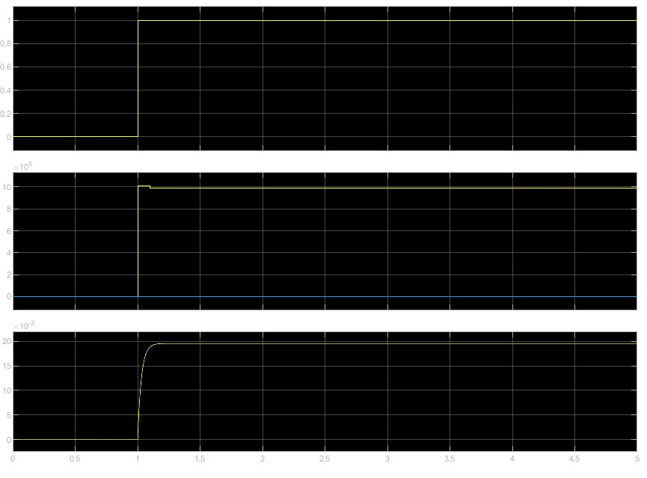

SimLink 02
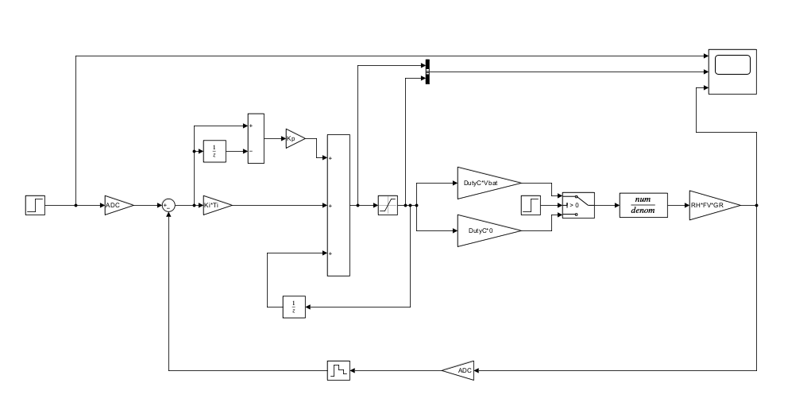

Voltage Change Scope Image (Step / Controller / System Outputs)
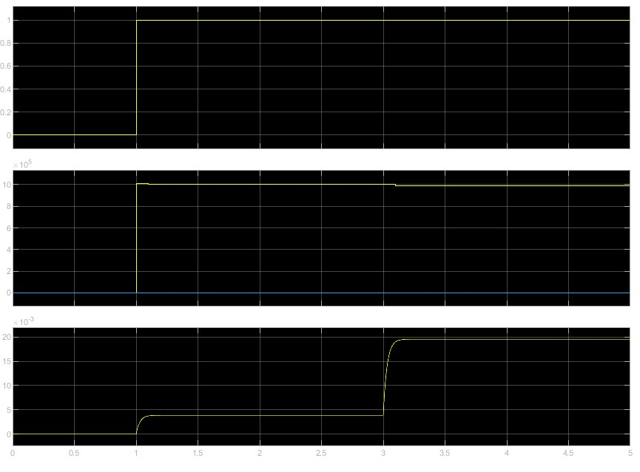

SimLink 03

Load Change Scope Image (Step / Controller / System Outputs)

Problems Encountered

Questions
- What is the fundamental difference between the simulation in Matlab and the simulation in Simulink?
a) Hint: Time domain
Answer:
- Is the controller designed in the discrete time domain or continuous time domain?
a) Hint: Have you been taught discrete control design?
Answer:
- Is the control implementation in the continuous domain? If not, how do we determine the discrete controller is stable in our operational range?
Answer:
- Is there some way to limit the major overshoot of the system?
a) Hint: Research Integral Anti-Windup
Answer:
- How did you determine the no load bandwidth and what frequencies can be rejected?
a) Does this match the input waveform performance?
Answer:

Requirements
- Check-off requirements:
  - Implantation of controller must use software interrupt (ticker function)
  - Comparison for Simulations and Implementation
    - Tabularized comparison chart completed
  - Description of derivation for control gains
  - Description of stability
    - Bode Plot
    - Nyquist stability criterion
  - Completion and demonstration of control implementation
    - Control system corrects for a drop in supply voltage.
    - Control system corrects for a load on the wheels.
- Check-off report: (Group)
  - Refer to rubric and template from Blackboard
  - Be sure to include:
    - Description of identification process
    - Description of the frequency sweep.
    - Derivation of Transfer Function
    - Description of Transfer Function Coefficients
    - Results presentation (include o-scope images, measurement records, etc.)
    - Results analysis and discussion
    - Hardware schematic (using PSpice, TinyCAD, EAGLE, etc.)
    - Problem-solving (describe problems you encountered and how you solved them)

Time Sheet
Name | Date | Start Time | End Time | Total Time Spent | Tasks / Notes
Nicholas George | 11/01/2023 | 13:00 | 14:30 | 1 Hr. 30 Min. | Lab Notebook 03 documentation

Component Specifications (Data Sheets)

Mbed Pinout
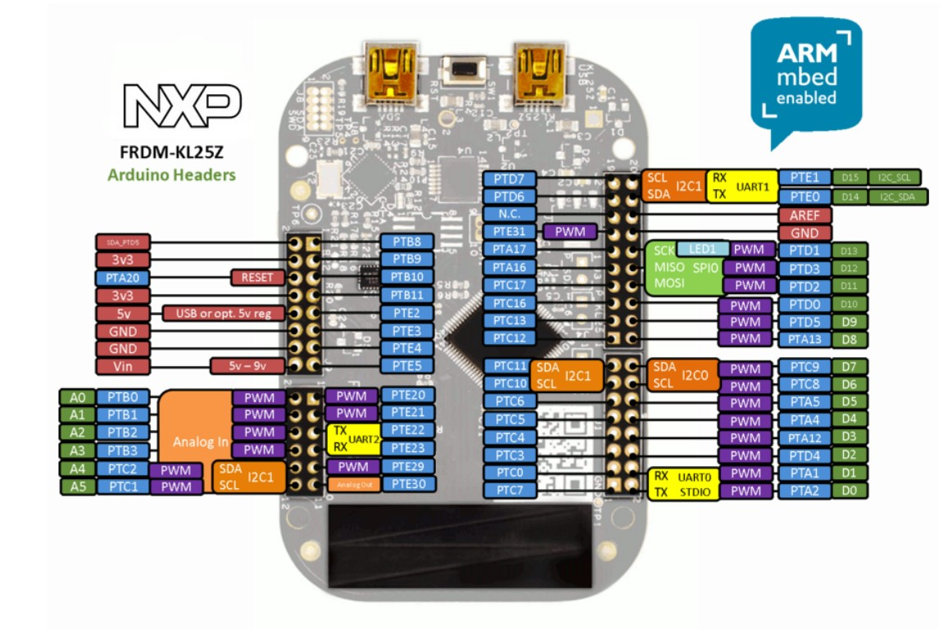

Mbed Datasheet
https://www.nxp.com/docs/en/data-sheet/KL25P80M48SF0.pdf

MOSFET (IRF540NPBF) Datasheet
https://www.infineon.com/dgdl/irf540npbf.pdf?fileId=5546d462533600a4015355e39f0d19a1

Schottky Diode (MBR1060-E3/45) Datasheet
https://www.vishay.com/docs/88669/mbr10xx.pdf

Motor (RN260-CN-18130) Datasheet
https://community.nxp.com/t5/University-Programs-Knowledge/Freescale-Cup-DC-Motor-Specifications/ta-p/1100465

Voltage Regulator (L7805CV) Datasheet
https://www.st.com/content/ccc/resource/technical/document/datasheet/41/4f/b3/b0/12/d4/47/88/CD00000444.pdf/files/CD00000444.pdf/jcr:content/translations/en.CD00000444.pdf

Low-Side Gate Driver (TC4428EPA) Datasheet
https://ww1.microchip.com/downloads/en/DeviceDoc/20001423J.pdf

Optical Sensor (OPB829AZ) Datasheet
https://www.ttelectronics.com/TTElectronics/media/ProductFiles/Datasheet/OPB827-829.pdf

Frequency to Voltage Converter (LM2907N/NOPB) Datasheet
https://www.ti.com/lit/ds/symlink/lm2907-n.pdf?ts=1694862043100&ref_url=https%253A%252F%252Fwww.google.com%252F

